**Android Framework**  
“The **Android Framework** is the entire stack of stuff that makes up the OS. This is the underlying Native libraries that are not directly accessible, the layer above that that you actually interact with and the code that developers write to run on the system”

**What is Android programming language?**

“Kotlin – Kotlin was recently introduced as a secondary 'official' Java **language**. It is similar to Java in many ways but is a little easier to get to grips with. C/C++ –**Android** Studio also supports C++ with the use of the Java NDK. This allows for native coding applications, which can be handy for things like games

**How does an android app work?**

Starting at the bottom is the Linux Kernel. **Android** uses Linux for its device drivers, memory management, process management, and networking. ... The next level up contains the **Android** native libraries. They are all written in C/C++ internally, but you'll be calling them through Java interfaces

**What is meant by activity in Android?**

An **activity** represents a single screen with a user interface just like window or frame of Java.**Android activity** is the subclass of ContextThemeWrapper class.

**ANDROID STUDIO**

**Android Studio** is the official integrated development environment (IDE) for Google's **Android** operating system, built on JetBrains' IntelliJ IDEA software and designed specifically for **Android** development. ... **Android Studio** was announced on May 16, 2013 at the Google I/O conference.

**APPLICATION PROGRAM INTERFACE**

An **application program interface** (API) is a set of routines, protocols, and tools for building software applications. Basically, an API specifies how software components should interact. Additionally, APIs are used when programming graphical user interface (GUI) components.

**What is the Gradle wrapper?**

When you use the **Gradle Wrapper**, you embed some intelligence into your project. When some one runs the build for the first time, they run “gradlew” which is an automatically generated shell script (or Batch script on Windows) designed to download **Gradle**.J

”  
  
Douglas Crockford first specified JSON. Image from 2007

What is JSON format?

**JSON**, or JavaScript Object Notation, is a minimal, readable **format** for structuring data. It is used primarily to transmit data between a server and web application, as an alternative to XML.

Server Clients Communication for data manipulation.  
Json parse is one of the most common use in android application.Ap APi Aur URL k through in json fromate main android main data/ information easily communicaton.

Json for use from the server to the client side data easily send hjata hai.

Its alternative of XML. Its is subset of javascript.

Android Support the PARSE JSON of the Array and Object (Collection OF Data)

ADVANTAGE

Its faster and read and write data easly its earies then XML for AJAX Application.

Its use array

USES  
AsynTask Class

It is allow to perform background task and operation and publish result on the UI Threads.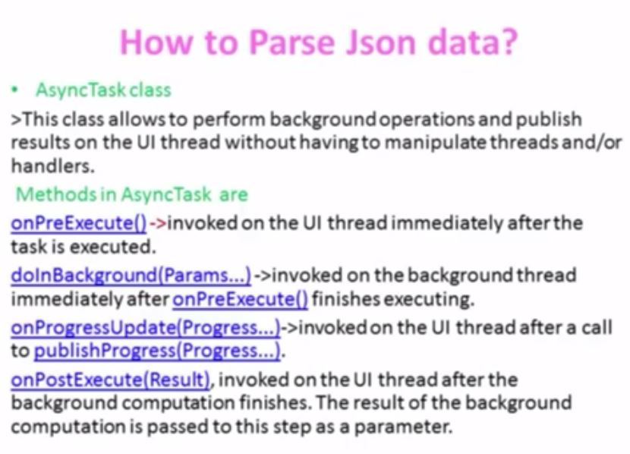

**GRID VIEW**Shows two dimentional data scrolling grid display like a rows and columns   
more then one components in onw row with using LAYOUTINFLATOR nad BASEADAPTER use between for data source and ADAPTERVIEW

baseADAPTER method()**getcount()** : return the counting number of images**getItem() :**  return the selected items**getItemId()** : return the id for selected items  
getView() : reutnr the view

______________________________________________

**Android Architecture?**

**FourElements**

**1.Application Develoepment**

**2.Framwork**

**3.Libraries**

**4.Kernel Linex**

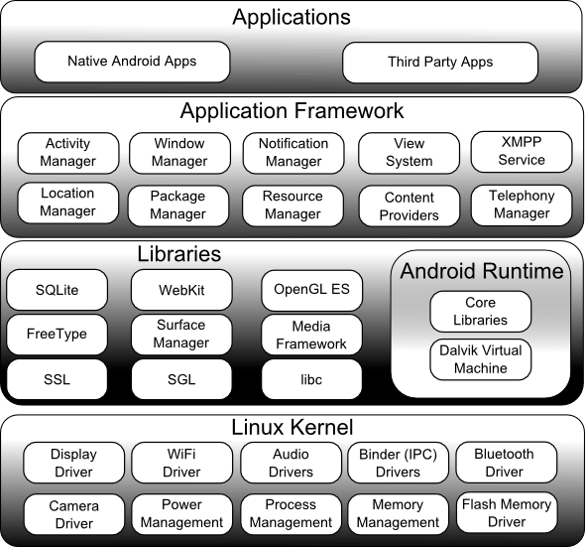

**What is SharedPreferences?**

**APP MENIFEST**

**ACTION:  
<action android:**[**name**](https://developer.android.com/guide/topics/manifest/action-element.html#nm)**="string" />**

**ACTIVITY:  
<activity android:**[**allowEmbedded**](https://developer.android.com/guide/topics/manifest/activity-element.html#embedded)**=["true" | "false"]  
          android:**[**allowTaskReparenting**](https://developer.android.com/guide/topics/manifest/activity-element.html#reparent)**=["true" | "false"]  
          android:**[**alwaysRetainTaskState**](https://developer.android.com/guide/topics/manifest/activity-element.html#always)**=["true" | "false"]  
          android:**[**autoRemoveFromRecents**](https://developer.android.com/guide/topics/manifest/activity-element.html#autoremrecents)**=["true" | "false"]  
          android:**[**banner**](https://developer.android.com/guide/topics/manifest/activity-element.html#banner)**="drawable resource"  
          android:**[**clearTaskOnLaunch**](https://developer.android.com/guide/topics/manifest/activity-element.html#clear)**=["true" | "false"]**          android:[colorMode](https://developer.android.com/guide/topics/manifest/activity-element.html#colormode)=[ "hdr" | "wideColorGamut"]  
          android:[configChanges](https://developer.android.com/guide/topics/manifest/activity-element.html#config)=["mcc", "mnc", "locale",  
                                 "touchscreen", "keyboard", "keyboardHidden",  
                                 "navigation", "screenLayout", "fontScale",  
                                 "uiMode", "orientation", "density",  
                                 "screenSize", "smallestScreenSize"]  
          android:[directBootAware](https://developer.android.com/guide/topics/manifest/activity-element.html#directBootAware)=["true" | "false"]  
          android:[documentLaunchMode](https://developer.android.com/guide/topics/manifest/activity-element.html#dlmode)=["intoExisting" | "always" |  
                                  "none" | "never"]  
          android:[enabled](https://developer.android.com/guide/topics/manifest/activity-element.html#enabled)=["true" | "false"]  
          android:[excludeFromRecents](https://developer.android.com/guide/topics/manifest/activity-element.html#exclude)=["true" | "false"]  
          android:[exported](https://developer.android.com/guide/topics/manifest/activity-element.html#exported)=["true" | "false"]  
          android:[finishOnTaskLaunch](https://developer.android.com/guide/topics/manifest/activity-element.html#finish)=["true" | "false"]  
          android:[hardwareAccelerated](https://developer.android.com/guide/topics/manifest/activity-element.html#hwaccel)=["true" | "false"]  
          android:[icon](https://developer.android.com/guide/topics/manifest/activity-element.html#icon)="*drawable resource*"  
          android:[label](https://developer.android.com/guide/topics/manifest/activity-element.html#label)="*string resource*"  
          android:[launchMode](https://developer.android.com/guide/topics/manifest/activity-element.html#lmode)=["standard" | "singleTop" |  
                              "singleTask" | "singleInstance"]  
          android:[maxRecents](https://developer.android.com/guide/topics/manifest/activity-element.html#maxrecents)="*integer*"  
          android:[maxAspectRatio](https://developer.android.com/guide/topics/manifest/activity-element.html#maxaspectratio)="*float*"  
          android:[multiprocess](https://developer.android.com/guide/topics/manifest/activity-element.html#multi)=["true" | "false"]  
          android:[name](https://developer.android.com/guide/topics/manifest/activity-element.html#nm)="*string*"  
          android:[noHistory](https://developer.android.com/guide/topics/manifest/activity-element.html#nohist)=["true" | "false"]    
          android:[parentActivityName](https://developer.android.com/guide/topics/manifest/activity-element.html#parent)="*string*"   
          android:[persistableMode](https://developer.android.com/guide/topics/manifest/activity-element.html#persistableMode)=["persistRootOnly" |   
                                   "persistAcrossReboots" | "persistNever"]  
          android:[permission](https://developer.android.com/guide/topics/manifest/activity-element.html#prmsn)="*string*"  
          android:[process](https://developer.android.com/guide/topics/manifest/activity-element.html#proc)="*string*"  
          android:[relinquishTaskIdentity](https://developer.android.com/guide/topics/manifest/activity-element.html#relinquish)=["true" | "false"]  
          android:[resizeableActivity](https://developer.android.com/guide/topics/manifest/activity-element.html#resizeableActivity)=["true" | "false"]  
          android:[screenOrientation](https://developer.android.com/guide/topics/manifest/activity-element.html#screen)=["unspecified" | "behind" |  
                                     "landscape" | "portrait" |  
                                     "reverseLandscape" | "reversePortrait" |  
                                     "sensorLandscape" | "sensorPortrait" |  
                                     "userLandscape" | "userPortrait" |  
                                     "sensor" | "fullSensor" | "nosensor" |  
                                     "user" | "fullUser" | "locked"]  
          android:[showForAllUsers](https://developer.android.com/guide/topics/manifest/activity-element.html#showForAllUsers)=["true" | "false"]  
          android:[stateNotNeeded](https://developer.android.com/guide/topics/manifest/activity-element.html#state)=["true" | "false"]  
          android:[supportsPictureInPicture](https://developer.android.com/guide/topics/manifest/activity-element.html#supportsPIP)=["true" | "false"]  
          android:[taskAffinity](https://developer.android.com/guide/topics/manifest/activity-element.html#aff)="*string*"  
          android:[theme](https://developer.android.com/guide/topics/manifest/activity-element.html#theme)="*resource or theme*"  
          android:[uiOptions](https://developer.android.com/guide/topics/manifest/activity-element.html#uioptions)=["none" | "splitActionBarWhenNarrow"]  
          android:[windowSoftInputMode](https://developer.android.com/guide/topics/manifest/activity-element.html#wsoft)=["stateUnspecified",  
                                       "stateUnchanged", "stateHidden",  
                                       "stateAlwaysHidden", "stateVisible",

                                       "stateAlwaysVisible", "adjustUnspecified",  
                                       "adjustResize", "adjustPan"] >     
    . . .  
</activity>

**ACTIVITY ALIAS:**<activity-alias android:[enabled](https://developer.android.com/guide/topics/manifest/activity-alias-element.html#enabled)=["true" | "false"]  
                android:[exported](https://developer.android.com/guide/topics/manifest/activity-alias-element.html#exported)=["true" | "false"]  
                android:[icon](https://developer.android.com/guide/topics/manifest/activity-alias-element.html#icon)="*drawable resource*"  
                android:[label](https://developer.android.com/guide/topics/manifest/activity-alias-element.html#label)="*string resource*"  
                android:[name](https://developer.android.com/guide/topics/manifest/activity-alias-element.html#nm)="*string*"  
                android:[permission](https://developer.android.com/guide/topics/manifest/activity-alias-element.html#prmsn)="*string*"  
                android:[targetActivity](https://developer.android.com/guide/topics/manifest/activity-alias-element.html#trgt)="*string*" >  
    . . .  
</activity-alias>

**APPLICATIONS:**<application android:[allowTaskReparenting](https://developer.android.com/guide/topics/manifest/application-element.html#reparent)=["true" | "false"]  
             android:[allowBackup](https://developer.android.com/guide/topics/manifest/application-element.html#allowbackup)=["true" | "false"]  
             android:[allowClearUserData](https://developer.android.com/guide/topics/manifest/application-element.html#allowClearUserData)=["true" | "false"]  
             android:[backupAgent](https://developer.android.com/guide/topics/manifest/application-element.html#agent)="*string*"  
             android:[backupInForeground](https://developer.android.com/guide/topics/manifest/application-element.html#backupInForeground)=["true" | "false"]  
             android:[banner](https://developer.android.com/guide/topics/manifest/application-element.html#banner)="*drawable resource*"  
             android:[debuggable](https://developer.android.com/guide/topics/manifest/application-element.html#debug)=["true" | "false"]  
             android:[description](https://developer.android.com/guide/topics/manifest/application-element.html#desc)="*string resource*"  
             android:[directBootAware](https://developer.android.com/guide/topics/manifest/application-element.html#directBootAware)=["true" | "false"]  
             android:[enabled](https://developer.android.com/guide/topics/manifest/application-element.html#enabled)=["true" | "false"]  
             android:[extractNativeLibs](https://developer.android.com/guide/topics/manifest/application-element.html#extractNativeLibs)=["true" | "false"]  
             android:[fullBackupContent](https://developer.android.com/guide/topics/manifest/application-element.html#fullBackupContent)="*string*"  
             android:[fullBackupOnly](https://developer.android.com/guide/topics/manifest/application-element.html#fullBackupOnly)=["true" | "false"]  
             android:[hasCode](https://developer.android.com/guide/topics/manifest/application-element.html#code)=["true" | "false"]  
             android:[hardwareAccelerated](https://developer.android.com/guide/topics/manifest/application-element.html#hwaccel)=["true" | "false"]  
             android:[icon](https://developer.android.com/guide/topics/manifest/application-element.html#icon)="*drawable resource*"  
             android:[isGame](https://developer.android.com/guide/topics/manifest/application-element.html#isGame)=["true" | "false"]  
             android:[killAfterRestore](https://developer.android.com/guide/topics/manifest/application-element.html#killrst)=["true" | "false"]  
             android:[largeHeap](https://developer.android.com/guide/topics/manifest/application-element.html#largeHeap)=["true" | "false"]  
             android:[label](https://developer.android.com/guide/topics/manifest/application-element.html#label)="*string resource*"  
             android:[logo](https://developer.android.com/guide/topics/manifest/application-element.html#logo)="*drawable resource*"  
             android:[manageSpaceActivity](https://developer.android.com/guide/topics/manifest/application-element.html#space)="*string*"  
             android:[name](https://developer.android.com/guide/topics/manifest/application-element.html#nm)="*string*"  
             android:[networkSecurityConfig](https://developer.android.com/guide/topics/manifest/application-element.html#networkSecurityConfig)="*xml resource*"  
             android:[permission](https://developer.android.com/guide/topics/manifest/application-element.html#prmsn)="*string*"  
             android:[persistent](https://developer.android.com/guide/topics/manifest/application-element.html#persistent)=["true" | "false"]  
             android:[process](https://developer.android.com/guide/topics/manifest/application-element.html#proc)="*string*"  
             android:[restoreAnyVersion](https://developer.android.com/guide/topics/manifest/application-element.html#restoreany)=["true" | "false"]  
             android:[requiredAccountType](https://developer.android.com/guide/topics/manifest/application-element.html#requiredAccountType)="*string*"  
             android:[resizeableActivity](https://developer.android.com/guide/topics/manifest/application-element.html#resizeableActivity)=["true" | "false"]  
             android:[restrictedAccountType](https://developer.android.com/guide/topics/manifest/application-element.html#restrictedAccountType)="*string*"  
             android:[supportsRtl](https://developer.android.com/guide/topics/manifest/application-element.html#supportsrtl)=["true" | "false"]  
             android:[taskAffinity](https://developer.android.com/guide/topics/manifest/application-element.html#aff)="*string*"  
             android:[testOnly](https://developer.android.com/guide/topics/manifest/application-element.html#testOnly)=["true" | "false"]  
             android:[theme](https://developer.android.com/guide/topics/manifest/application-element.html#theme)="*resource or theme*"  
             android:[uiOptions](https://developer.android.com/guide/topics/manifest/application-element.html#uioptions)=["none" | "splitActionBarWhenNarrow"]  
             android:[usesCleartextTraffic](https://developer.android.com/guide/topics/manifest/application-element.html#usesCleartextTraffic)=["true" | "false"]  
             android:[vmSafeMode](https://developer.android.com/guide/topics/manifest/application-element.html#vmSafeMode)=["true" | "false"] >  
    . . .  
</application>

**CATEGORY:**<category android:[name](https://developer.android.com/guide/topics/manifest/category-element.html#nm)="*string*" />

**COMPATABLE SCREENS:**<[compatible-screens](https://developer.android.com/guide/topics/manifest/compatible-screens-element.html#compatible-screens)>  
    <[screen](https://developer.android.com/guide/topics/manifest/compatible-screens-element.html#screen) android:[screenSize](https://developer.android.com/guide/topics/manifest/compatible-screens-element.html#screenSize)=["small" | "normal" | "large" | "xlarge"]  
            android:[screenDensity](https://developer.android.com/guide/topics/manifest/compatible-screens-element.html#screenDensity)=["ldpi" | "mdpi" | "hdpi" | "xhdpi"  
                                   | "280" | "360" | "420" | "480" | "560" ] />  
    ...  
</compatible-screens>

**GRANT URI PERMISSION:**<grant-uri-permission android:[path](https://developer.android.com/guide/topics/manifest/grant-uri-permission-element.html#path)="*string*"  
                      android:[pathPattern](https://developer.android.com/guide/topics/manifest/grant-uri-permission-element.html#path)="*string*"  
                      android:[pathPrefix](https://developer.android.com/guide/topics/manifest/grant-uri-permission-element.html#path)="*string*" />

**INSTRUMENTATION:**<instrumentation android:[functionalTest](https://developer.android.com/guide/topics/manifest/instrumentation-element.html#ftest)=["true" | "false"]  
                 android:[handleProfiling](https://developer.android.com/guide/topics/manifest/instrumentation-element.html#hprof)=["true" | "false"]  
                 android:[icon](https://developer.android.com/guide/topics/manifest/instrumentation-element.html#icon)="*drawable resource*"  
                 android:[label](https://developer.android.com/guide/topics/manifest/instrumentation-element.html#label)="*string resource*"  
                 android:[name](https://developer.android.com/guide/topics/manifest/instrumentation-element.html#nm)="*string*"  
                 android:[targetPackage](https://developer.android.com/guide/topics/manifest/instrumentation-element.html#trgt)="*string*" />

**INTENT-FILTER:**<intent-filter android:[icon](https://developer.android.com/guide/topics/manifest/intent-filter-element.html#icon)="*drawable resource*"  
               android:[label](https://developer.android.com/guide/topics/manifest/intent-filter-element.html#label)="*string resource*"  
               android:[priority](https://developer.android.com/guide/topics/manifest/intent-filter-element.html#priority)="*integer*" >  
    . . .  
</intent-filter>

**MENIFEST:**<manifest xmlns:[android](https://developer.android.com/guide/topics/manifest/manifest-element.html#nspace)="http://schemas.android.com/apk/res/android"  
          [package](https://developer.android.com/guide/topics/manifest/manifest-element.html#package)="*string*"  
          android:[sharedUserId](https://developer.android.com/guide/topics/manifest/manifest-element.html#uid)="*string*"  
          android:[sharedUserLabel](https://developer.android.com/guide/topics/manifest/manifest-element.html#uidlabel)="*string resource*"   
          android:[versionCode](https://developer.android.com/guide/topics/manifest/manifest-element.html#vcode)="*integer*"  
          android:[versionName](https://developer.android.com/guide/topics/manifest/manifest-element.html#vname)="*string*"  
          android:[installLocation](https://developer.android.com/guide/topics/manifest/manifest-element.html#install)=["auto" | "internalOnly" | "preferExternal"] >  
    . . .  
</manifest>

**META DATA:**<meta-data android:[name](https://developer.android.com/guide/topics/manifest/meta-data-element.html#nm)="*string*"  
           android:[resource](https://developer.android.com/guide/topics/manifest/meta-data-element.html#rsrc)="*resource specification*"  
           android:[value](https://developer.android.com/guide/topics/manifest/meta-data-element.html#val)="*string*" />

**PATH PERMISSON:**<path-permission android:[path](https://developer.android.com/guide/topics/manifest/path-permission-element.html#path)="*string*"  
                 android:[pathPrefix](https://developer.android.com/guide/topics/manifest/path-permission-element.html#pathPrefix)="*string*"  
                 android:[pathPattern](https://developer.android.com/guide/topics/manifest/path-permission-element.html#pathPattern)="*string*"  
                 android:[permission](https://developer.android.com/guide/topics/manifest/path-permission-element.html#permission)="*string*"  
                 android:[readPermission](https://developer.android.com/guide/topics/manifest/path-permission-element.html#readPermission)="*string*"  
                 android:[writePermission](https://developer.android.com/guide/topics/manifest/path-permission-element.html#writePermission)="*string*" />

**PERMISSION:**<permission android:[description](https://developer.android.com/guide/topics/manifest/permission-element.html#desc)="*string resource*"  
            android:[icon](https://developer.android.com/guide/topics/manifest/permission-element.html#icon)="*drawable resource*"  
            android:[label](https://developer.android.com/guide/topics/manifest/permission-element.html#label)="*string resource*"  
            android:[name](https://developer.android.com/guide/topics/manifest/permission-element.html#nm)="*string*"  
            android:[permissionGroup](https://developer.android.com/guide/topics/manifest/permission-element.html#pgroup)="*string*"  
            android:[protectionLevel](https://developer.android.com/guide/topics/manifest/permission-element.html#plevel)=["normal" | "dangerous" |  
                                     "signature" | "signatureOrSystem"] />

**PERMISSION GROUP:**<permission-group android:[description](https://developer.android.com/guide/topics/manifest/permission-group-element.html#desc)="*string resource*"

android:[icon](https://developer.android.com/guide/topics/manifest/permission-group-element.html#icon)="*drawable resource*"

android:[label](https://developer.android.com/guide/topics/manifest/permission-group-element.html#label)="*string resource*"

android:[name](https://developer.android.com/guide/topics/manifest/permission-group-element.html#nm)="*string*" />

**PERMISSION TREE:**<permission-tree android:[icon](https://developer.android.com/guide/topics/manifest/permission-tree-element.html#icon)="*drawable resource*"  
                 android:[label](https://developer.android.com/guide/topics/manifest/permission-tree-element.html#label)="*string resource*" ]  
                 android:[name](https://developer.android.com/guide/topics/manifest/permission-tree-element.html#nm)="*string*" />

**Providers:**<provider android:[authorities](https://developer.android.com/guide/topics/manifest/provider-element.html#auth)="*list*"  
          android:[directBootAware](https://developer.android.com/guide/topics/manifest/provider-element.html#directBootAware)=["true" | "false"]  
          android:[enabled](https://developer.android.com/guide/topics/manifest/provider-element.html#enabled)=["true" | "false"]  
          android:[exported](https://developer.android.com/guide/topics/manifest/provider-element.html#exported)=["true" | "false"]  
          android:[grantUriPermissions](https://developer.android.com/guide/topics/manifest/provider-element.html#gprmsn)=["true" | "false"]  
          android:[icon](https://developer.android.com/guide/topics/manifest/provider-element.html#icon)="*drawable resource*"  
          android:[initOrder](https://developer.android.com/guide/topics/manifest/provider-element.html#init)="*integer*"  
          android:[label](https://developer.android.com/guide/topics/manifest/provider-element.html#label)="*string resource*"  
          android:[multiprocess](https://developer.android.com/guide/topics/manifest/provider-element.html#multi)=["true" | "false"]  
          android:[name](https://developer.android.com/guide/topics/manifest/provider-element.html#nm)="*string*"  
          android:[permission](https://developer.android.com/guide/topics/manifest/provider-element.html#prmsn)="*string*"  
          android:[process](https://developer.android.com/guide/topics/manifest/provider-element.html#proc)="*string*"  
          android:[readPermission](https://developer.android.com/guide/topics/manifest/provider-element.html#rprmsn)="*string*"  
          android:[syncable](https://developer.android.com/guide/topics/manifest/provider-element.html#sync)=["true" | "false"]  
          android:[writePermission](https://developer.android.com/guide/topics/manifest/provider-element.html#wprmsn)="*string*" >  
    . . .  
</provider>

**RECIVERS**<receiver android:[directBootAware](https://developer.android.com/guide/topics/manifest/receiver-element.html#directBootAware)=["true" | "false"]  
          android:[enabled](https://developer.android.com/guide/topics/manifest/receiver-element.html#enabled)=["true" | "false"]  
          android:[exported](https://developer.android.com/guide/topics/manifest/receiver-element.html#exported)=["true" | "false"]  
          android:[icon](https://developer.android.com/guide/topics/manifest/receiver-element.html#icon)="*drawable resource*"  
          android:[label](https://developer.android.com/guide/topics/manifest/receiver-element.html#label)="*string resource*"  
          android:[name](https://developer.android.com/guide/topics/manifest/receiver-element.html#nm)="*string*"  
          android:[permission](https://developer.android.com/guide/topics/manifest/receiver-element.html#prmsn)="*string*"  
          android:[process](https://developer.android.com/guide/topics/manifest/receiver-element.html#proc)="*string*" >  
    . . .  
</receiver>

**SERVICES:** <service android:[description](https://developer.android.com/guide/topics/manifest/service-element.html#desc)="*string resource*"  
         android:[directBootAware](https://developer.android.com/guide/topics/manifest/service-element.html#directBootAware)=["true" | "false"]  
         android:[enabled](https://developer.android.com/guide/topics/manifest/service-element.html#enabled)=["true" | "false"]  
         android:[exported](https://developer.android.com/guide/topics/manifest/service-element.html#exported)=["true" | "false"]  
         android:[icon](https://developer.android.com/guide/topics/manifest/service-element.html#icon)="*drawable resource*"  
         android:[isolatedProcess](https://developer.android.com/guide/topics/manifest/service-element.html#isolated)=["true" | "false"]  
         android:[label](https://developer.android.com/guide/topics/manifest/service-element.html#label)="*string resource*"  
         android:[name](https://developer.android.com/guide/topics/manifest/service-element.html#nm)="*string*"  
         android:[permission](https://developer.android.com/guide/topics/manifest/service-element.html#prmsn)="*string*"  
         android:[process](https://developer.android.com/guide/topics/manifest/service-element.html#proc)="*string*" >  
    . . .  
</service>

**SDK**

<uses-sdk>

SYNTAX:

<uses-sdk android:[minSdkVersion](https://developer.android.com/guide/topics/manifest/uses-sdk-element.html#min)="*integer*"  
          android:[targetSdkVersion](https://developer.android.com/guide/topics/manifest/uses-sdk-element.html#target)="*integer*"  
          android:[maxSdkVersion](https://developer.android.com/guide/topics/manifest/uses-sdk-element.html#max)="*integer*" />

**RESPONSIVE LAYOUTS SUPPORT DEVICES**

**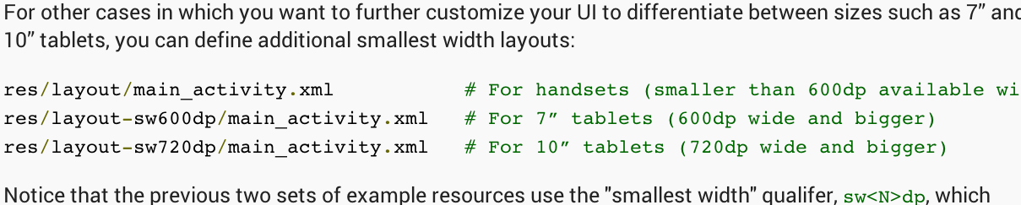  
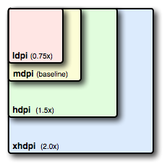**

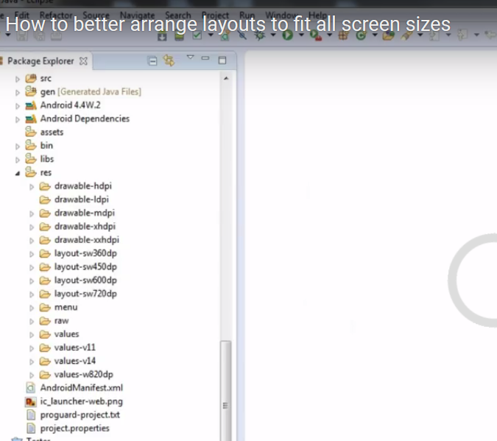

**MENIFEST**

[<supports-screens />](https://developer.android.com/guide/topics/manifest/supports-screens-element.html)    
    [<compatible-screens />](https://developer.android.com/guide/topics/manifest/compatible-screens-element.html)

<supports-screens android:[resizeable](https://developer.android.com/guide/topics/manifest/supports-screens-element.html#resizeable)=["true"| "false"]  
                  android:[smallScreens](https://developer.android.com/guide/topics/manifest/supports-screens-element.html#small)=["true" | "false"]  
                  android:[normalScreens](https://developer.android.com/guide/topics/manifest/supports-screens-element.html#normal)=["true" | "false"]  
                  android:[largeScreens](https://developer.android.com/guide/topics/manifest/supports-screens-element.html#large)=["true" | "false"]  
                  android:[xlargeScreens](https://developer.android.com/guide/topics/manifest/supports-screens-element.html#xlarge)=["true" | "false"]  
                  android:[anyDensity](https://developer.android.com/guide/topics/manifest/supports-screens-element.html#any)=["true" | "false"]  
                  android:[requiresSmallestWidthDp](https://developer.android.com/guide/topics/manifest/supports-screens-element.html#requiresSmallest)="*integer*"  
                  android:[compatibleWidthLimitDp](https://developer.android.com/guide/topics/manifest/supports-screens-element.html#compatibleWidth)="*integer*"  
                  android:[largestWidthLimitDp](https://developer.android.com/guide/topics/manifest/supports-screens-element.html#largestWidth)="*integer*"/>

<supports-screens android:compatibleWidthLimitDp="320" />

</manifest>

small 360dp

normal bigger devices 450dp

7 devices 600dp

10 devices 720dp

for Bigger Devices like tablets TVs 800dp

Configuration examples

To help you target some of your designs for different types of devices, here are some numbers for typical screen widths:

320dp: a typical phone screen (240x320 ldpi, 320x480 mdpi, 480x800 hdpi, etc).

480dp: a tweener tablet like the Streak (480x800 mdpi).

600dp: a 7” tablet (600x1024 mdpi).

720dp: a 10” tablet (720x1280 mdpi, 800x1280 mdpi, etc).

res/layout/main_activity.xml # For handsets

res/layout-sw600dp/main_activity.xml # For tablets

res/layout/main_activity.xml # For handsets (smaller than 600dp available width)

res/layout-sw600dp/main_activity.xml # For 7” tablets (600dp wide and bigger)

res/layout-sw720dp/main_activity.xml # For 10” tablets (720dp wide and bigger)

res/layout/main_activity.xml # For handsets (smaller than 600dp available width)

res/layout-w600dp/main_activity.xml # Multi-pane (any screen with 600dp available width or more)

smallestWidth sw<N>dp

Examples:

sw600dp

sw720dp

Available screen width w<N>dp

Examples:

w720dp

w1024dp

Available screen height h<N>dp

Examples:

h720dp

h1024dp

etc.

Screen Densties

36x36 (0.75x) for low-density

48x48 (1.0x baseline) for medium-density

72x72 (1.5x) for high-density

96x96 (2.0x) for extra-high-density

144x144 (3.0x) for extra-extra-high-density

192x192 (4.0x) for extra-extra-extra-high-density

res/layout/my_layout.xml // layout for normal screen size

res/layout-land/my_layout.xml // layout for normal-Landscape screen size

res/layout-small/my_layout.xml // layout for small screen size

res/layou-small-landt/my_layout.xml // layout for small-Landscape screen size

res/layout-large/my_layout.xml // layout for large screen size

res/layout-large-land/my_layout.xml // layout for large screen size in landscape mode

res/layout-xlarge/my_layout.xml // layout for xlarge screen size

res/layout-xlarge-land/my_layout.xml // layout for xlarge screen size in landscape mode

public class MyActivity extends Activity

{

@Override protected void onCreate(Bundle savedInstanceState)

{

super.onCreate();

Configuration config = getResources().getConfiguration();

if (config.smallestScreenWidthDp >= 600)

{

setContentView(R.layout.main_activity_tablet);

}

else

{

setContentView(R.layout.main_activity);

}

}

}

<manifest ... >

<supports-screens android:requiresSmallestWidthDp="600" />

...

</manifest>

xlarge screens are at least 960dp x 720dp

large screens are at least 640dp x 480dp

normal screens are at least 470dp x 320dp

small screens are at least 426dp x 320dp

Android Screen Sizes

720 x 1280

768 x 1280

800 x 1280

1080 x 1920

1440 x 2560

layout

small 2 -- 3.7

normal 3.7 -- 4.3

large 4.0 -- 7.1

extra large Like Tables 7.0 -- 10.0

___________________________

layout-sw320dp

layout-sw480dp

layout-sw600dp

layout-sw720dp

_________________

app icon

ldpi =36*36(pixel)

mdpi=48*48(pixel)

hdpi =72*72(pixel)

x-hdpi = 96*96(pixel)

xx-hdpi = 144*144(pixel)

Ratio

3:4:6:8

___________________________

BG-Image

ldpi =240*320(pixel)

mdpi=320*480(pixel)

hdpi =480*800(pixel)

x-hdpi = 720*1280(pixel)

|  |  |  |
| --- | --- | --- |
| Asset Type | Prefix | Example |
| Icons | ic_ | ic_star.png |
| Launcher icons | ic_launcher | ic_launcher_calendar.png |
| Menu icons and Action Bar icons | ic_menu | ic_menu_archive.png |
| Status bar icons | ic_stat_notify | ic_stat_notify_msg.png |
| Tab icons | ic_tab | ic_tab_recent.png |
| Dialog icons | ic_dialog | ic_dialog_info.png |

**FRAGMENTS:**

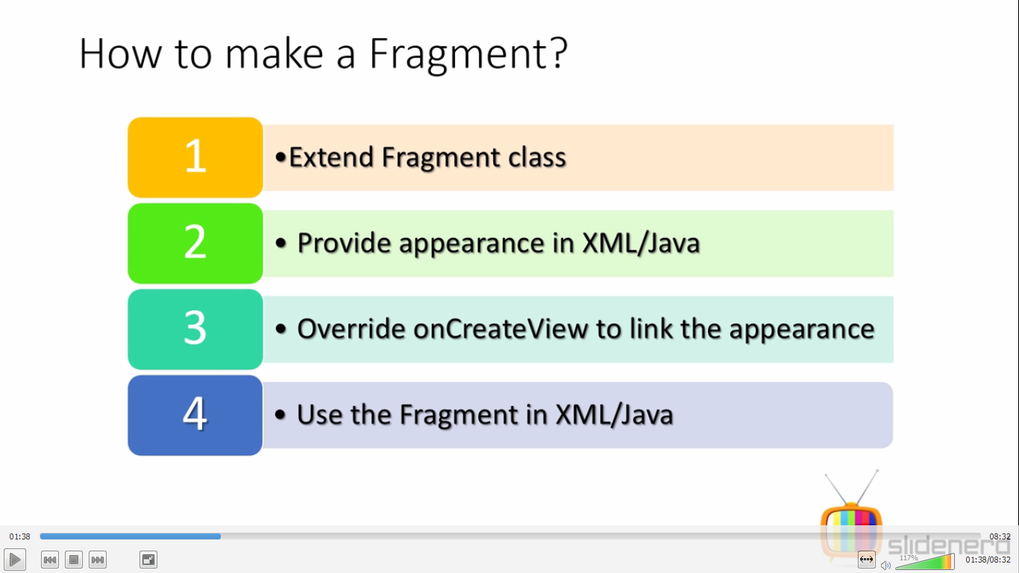

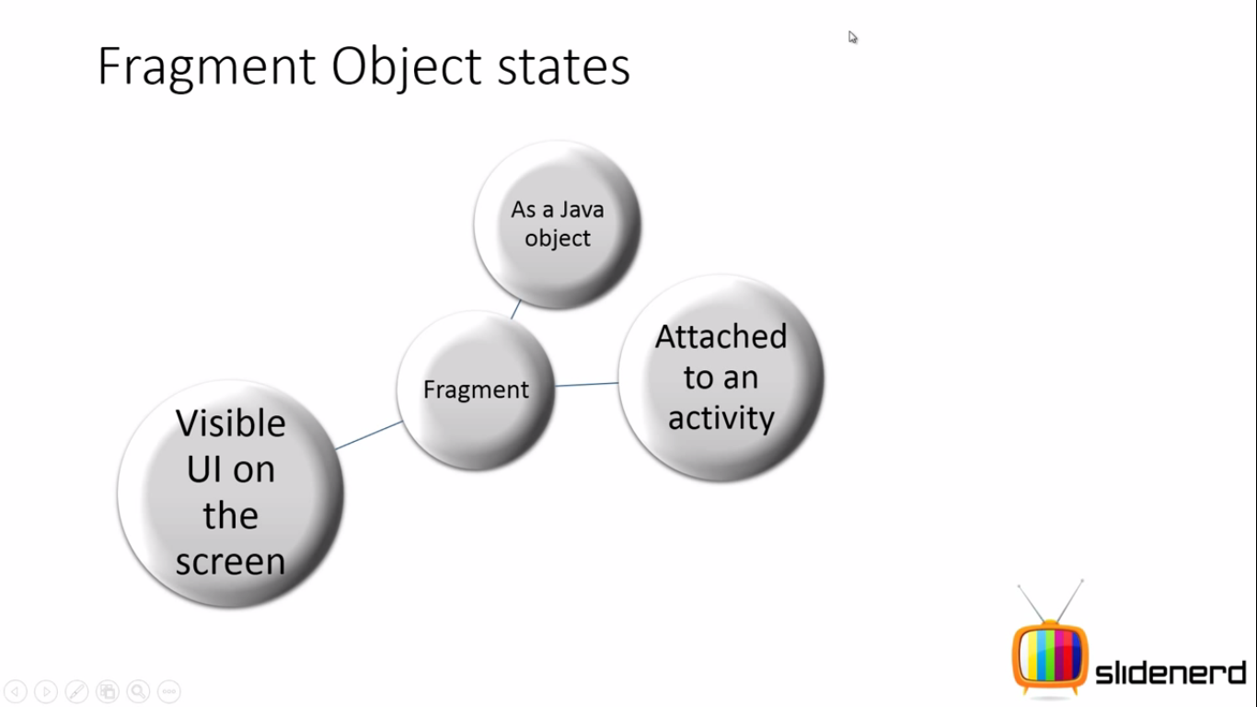

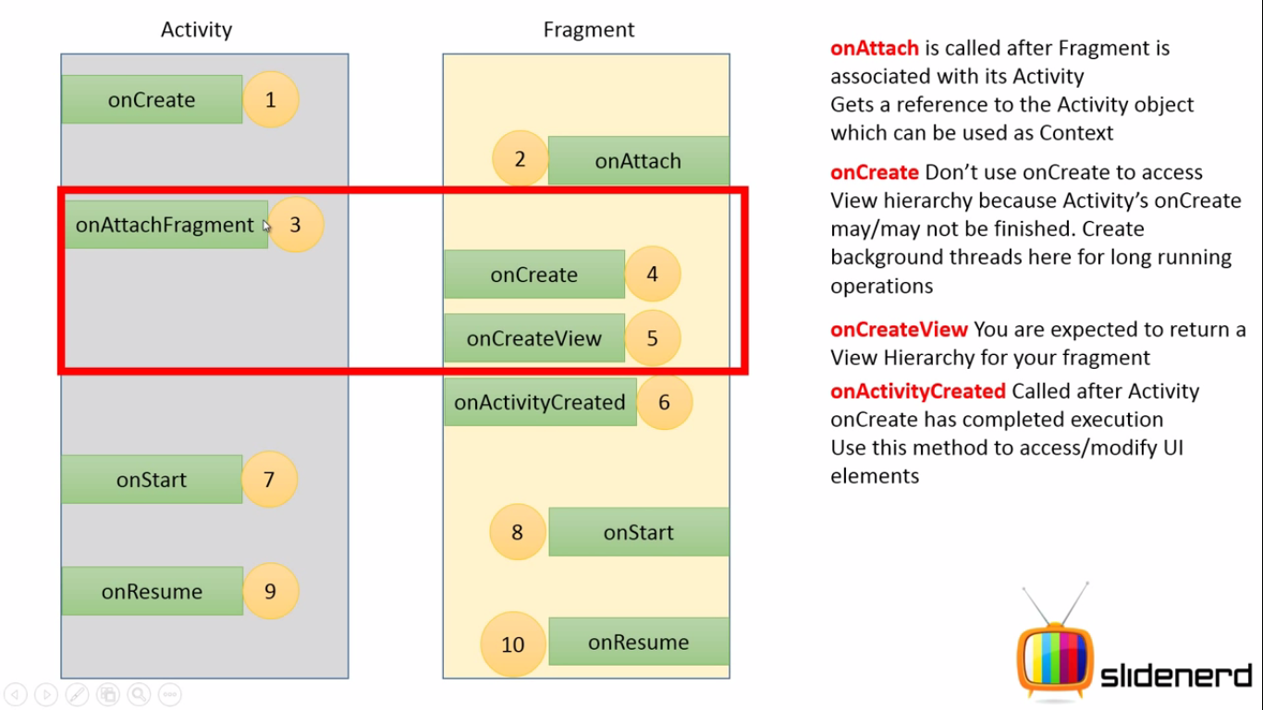

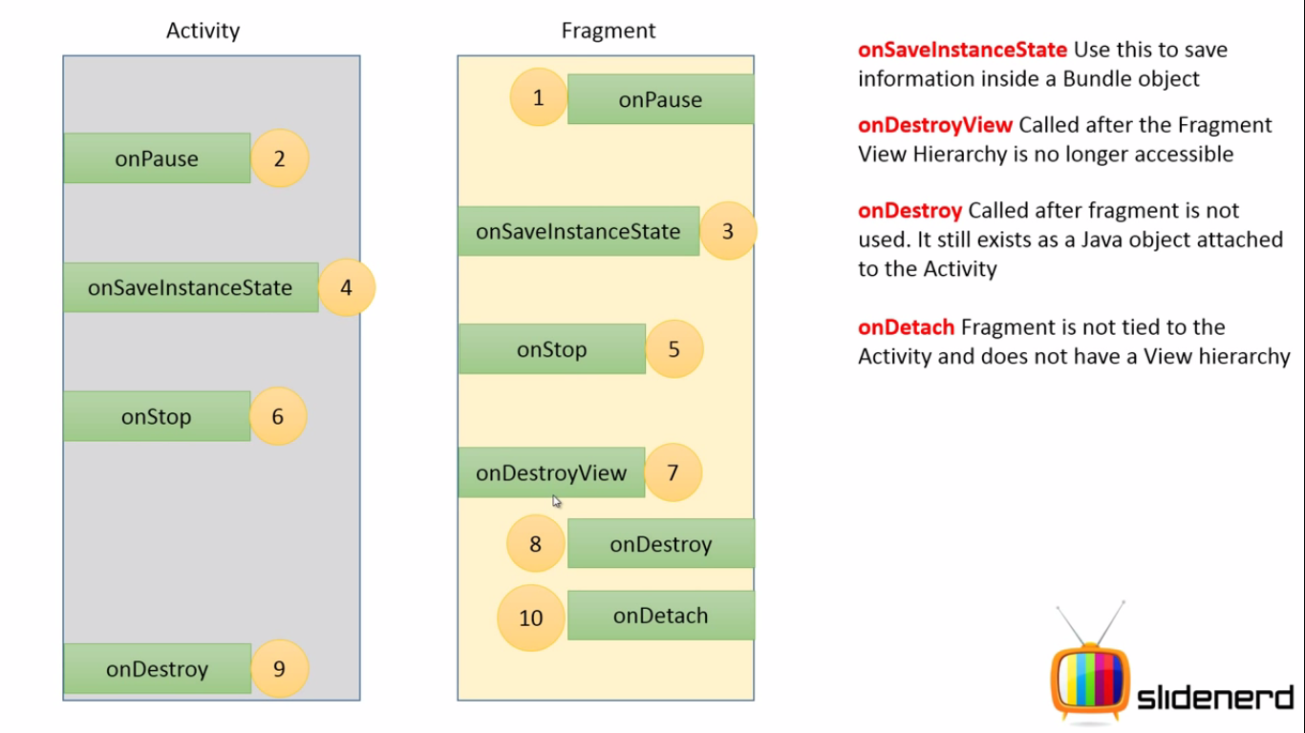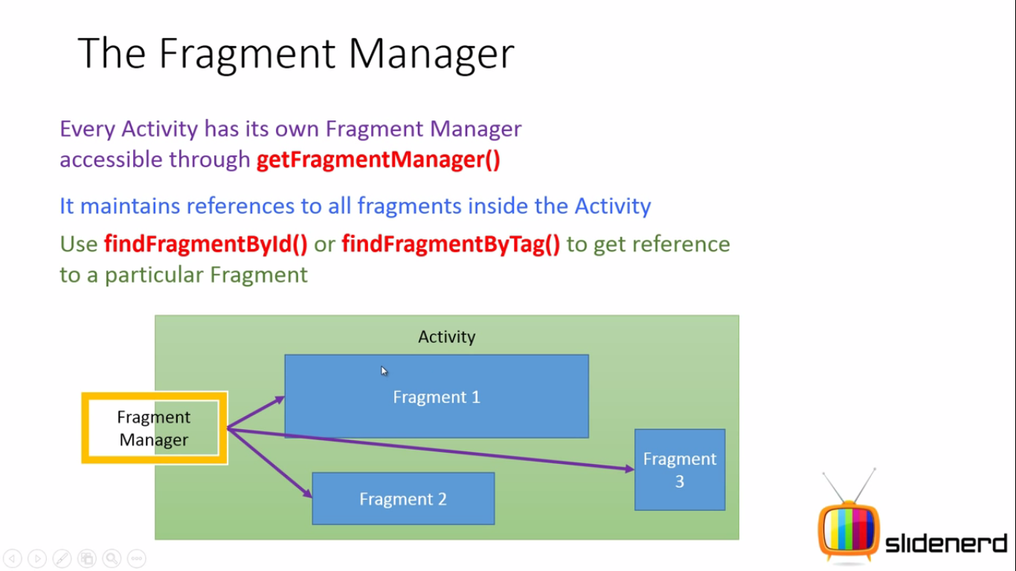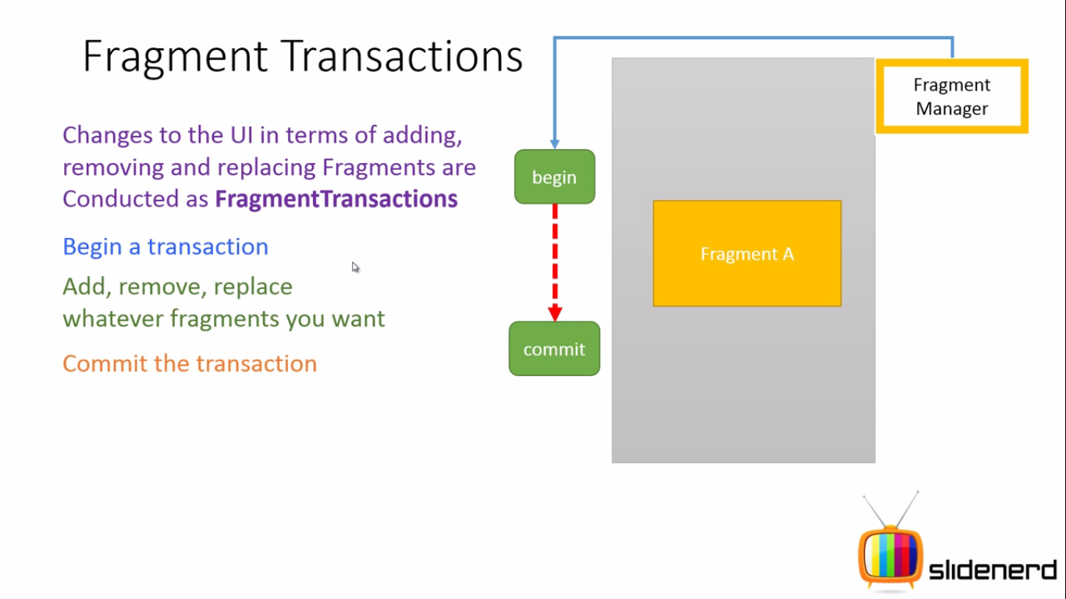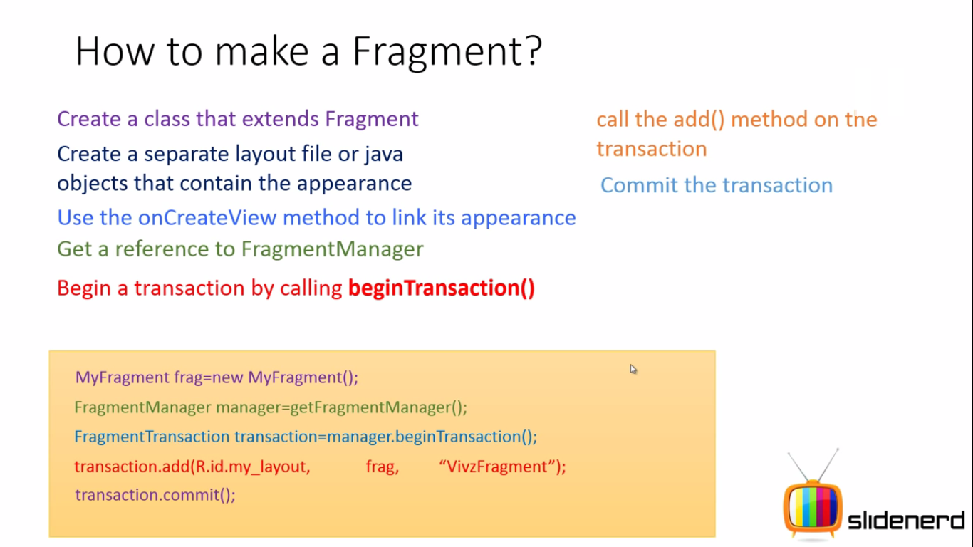

**STYLE Button Selector**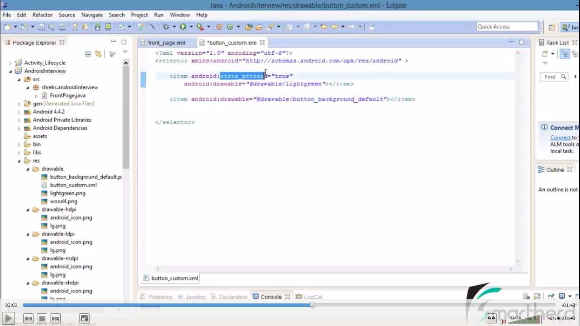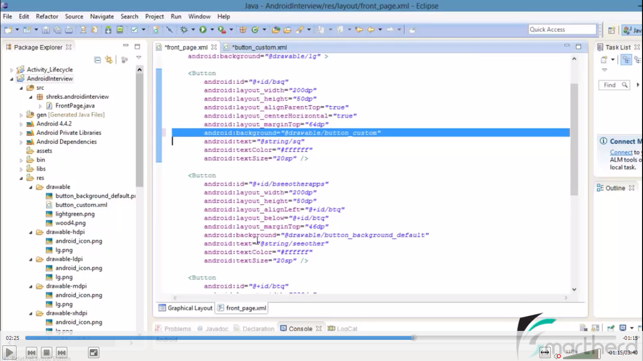

**FRAGMENTS:**

**Fragments Create Module in Android Layouts  
In an ativity you can add two activity frams like dynamic layouts .  
ALSO CALLED Special Class Activity  
ActionBarActivity is the subclass of Fragement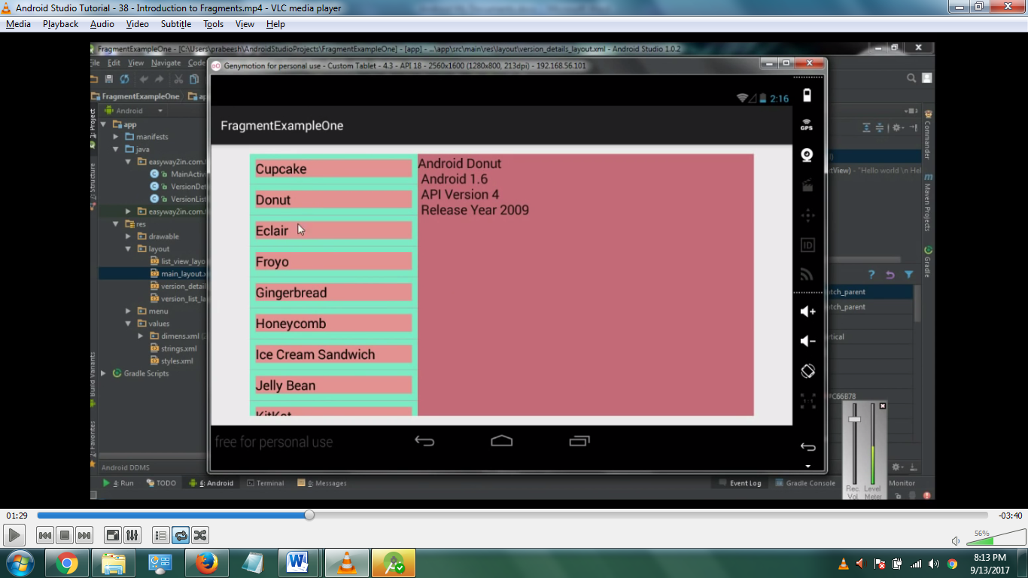 Fragment Replacement first to second one UserLoging & New UserLogin**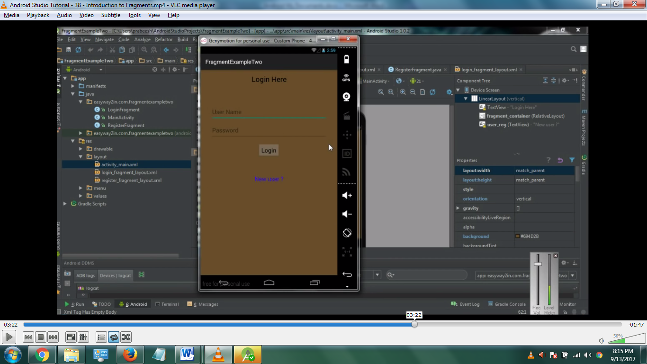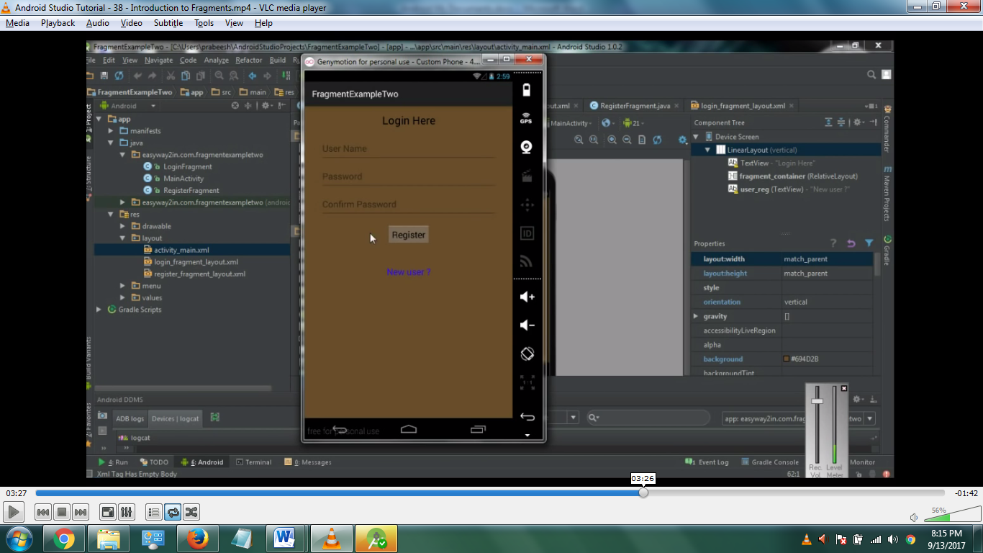

**Version API ANDROID STUDIO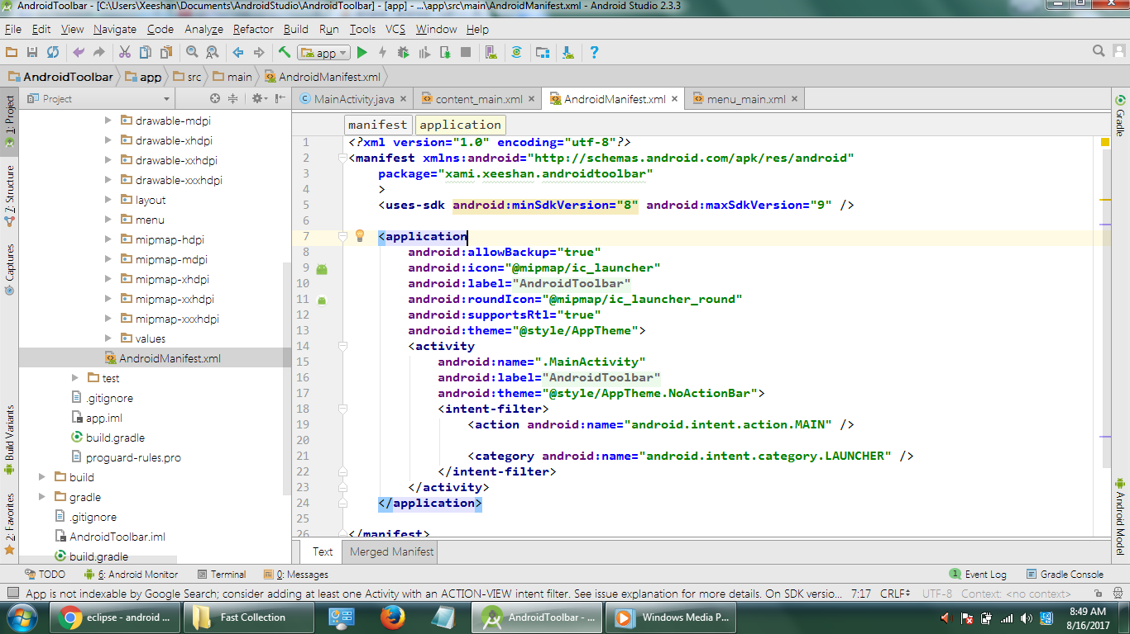 TOOLBAR**

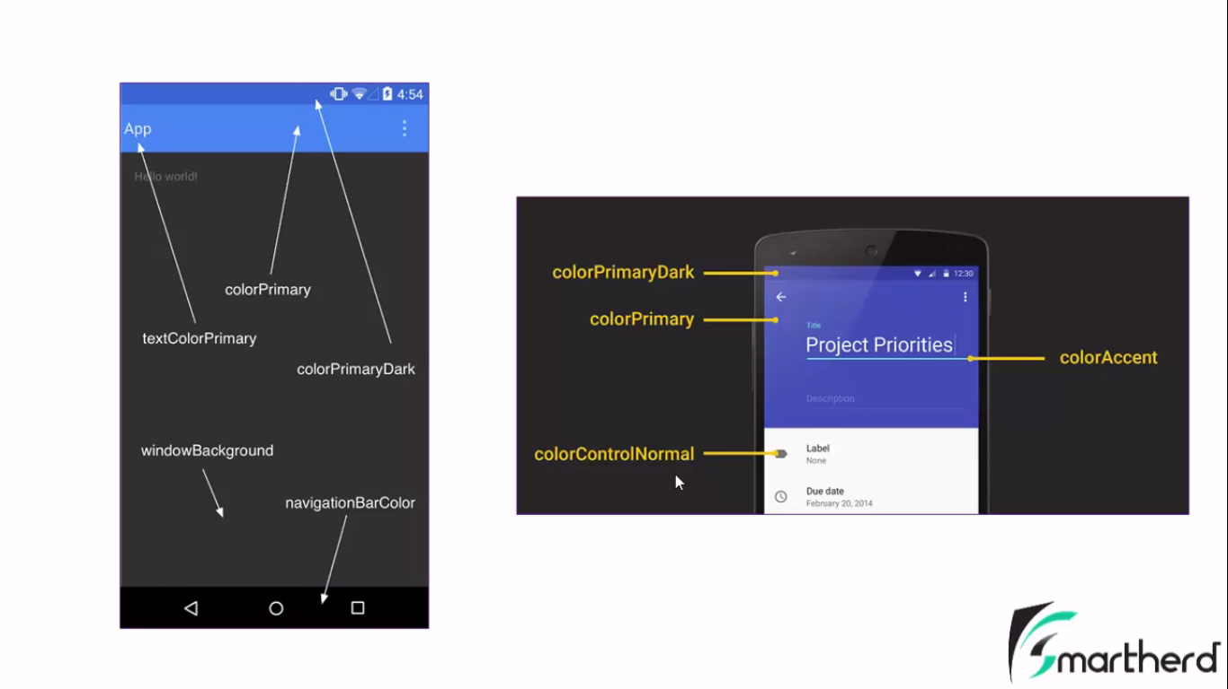

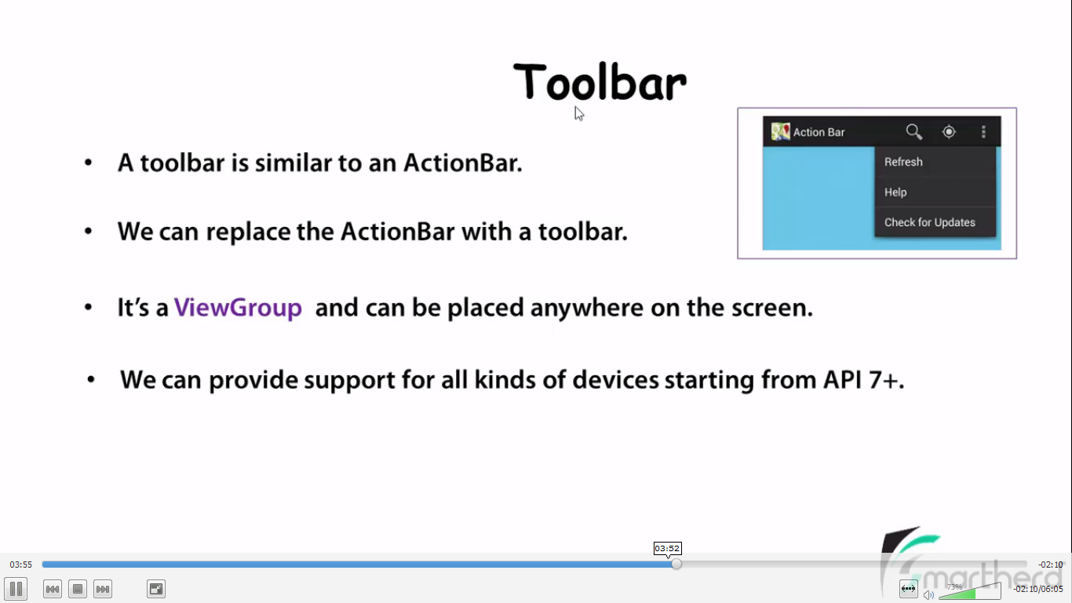

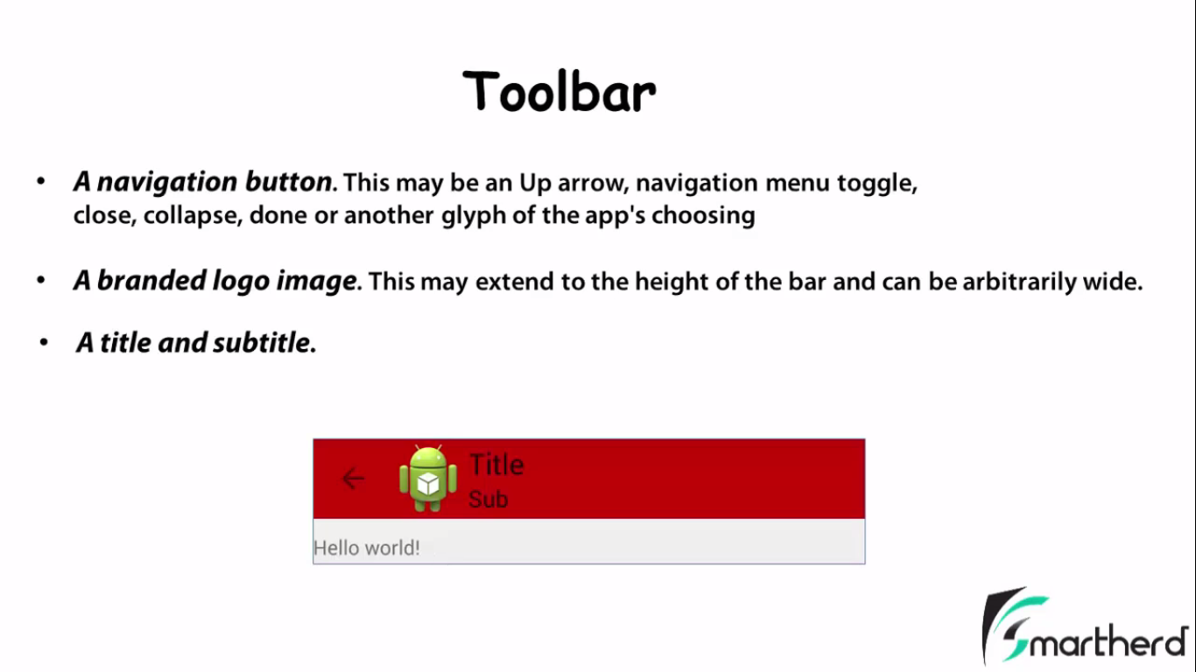

**TOOLBAR is jst like a ViewGroup**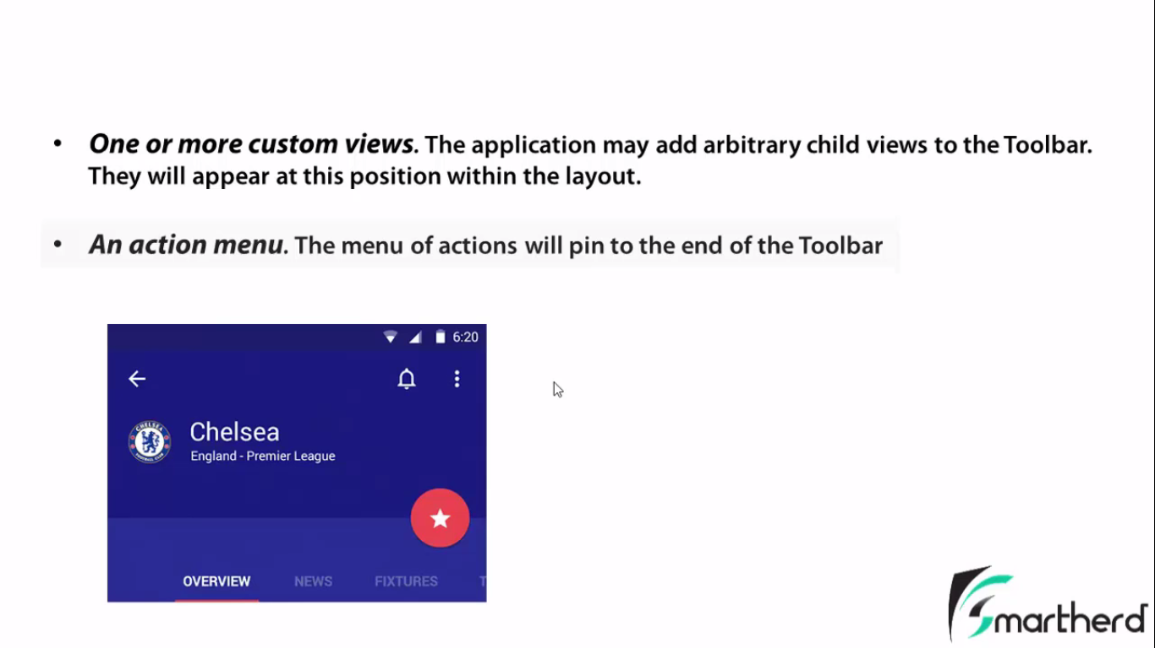

**NOTIFICATION:**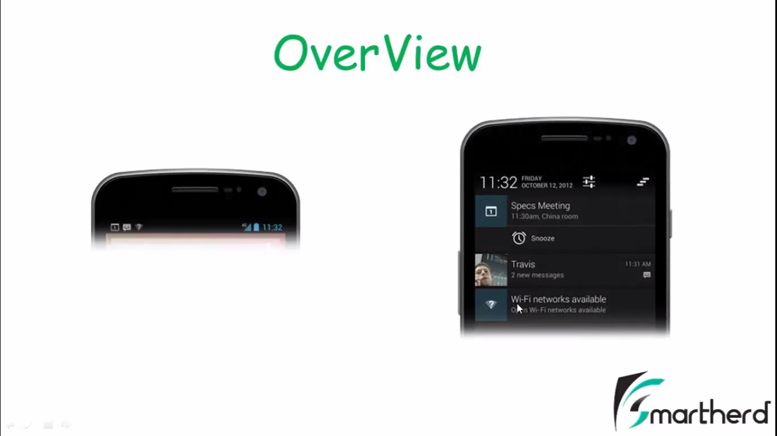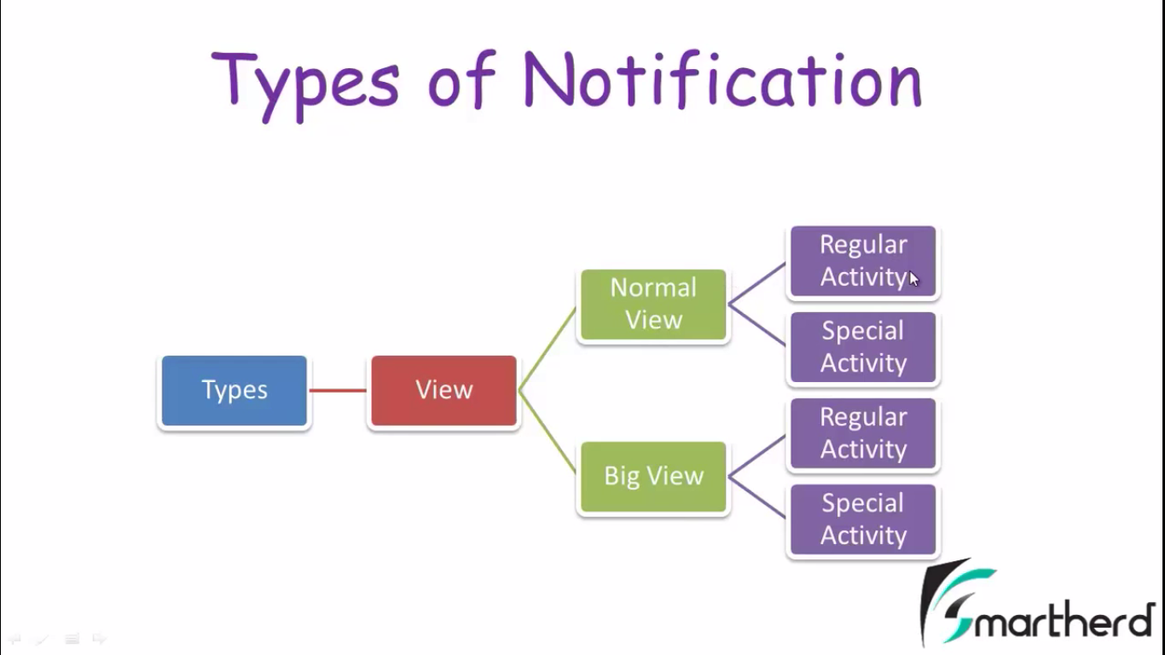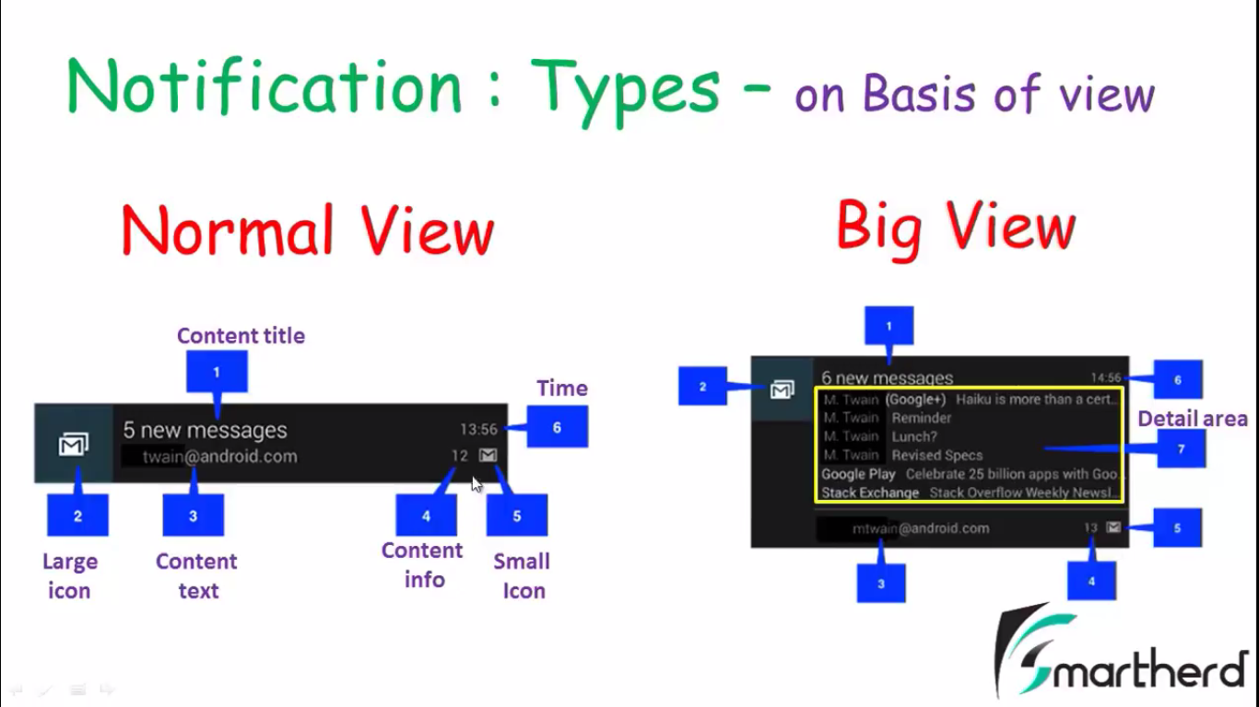

**BROADCAST BIG VIEW CATEGORIES 🡪**

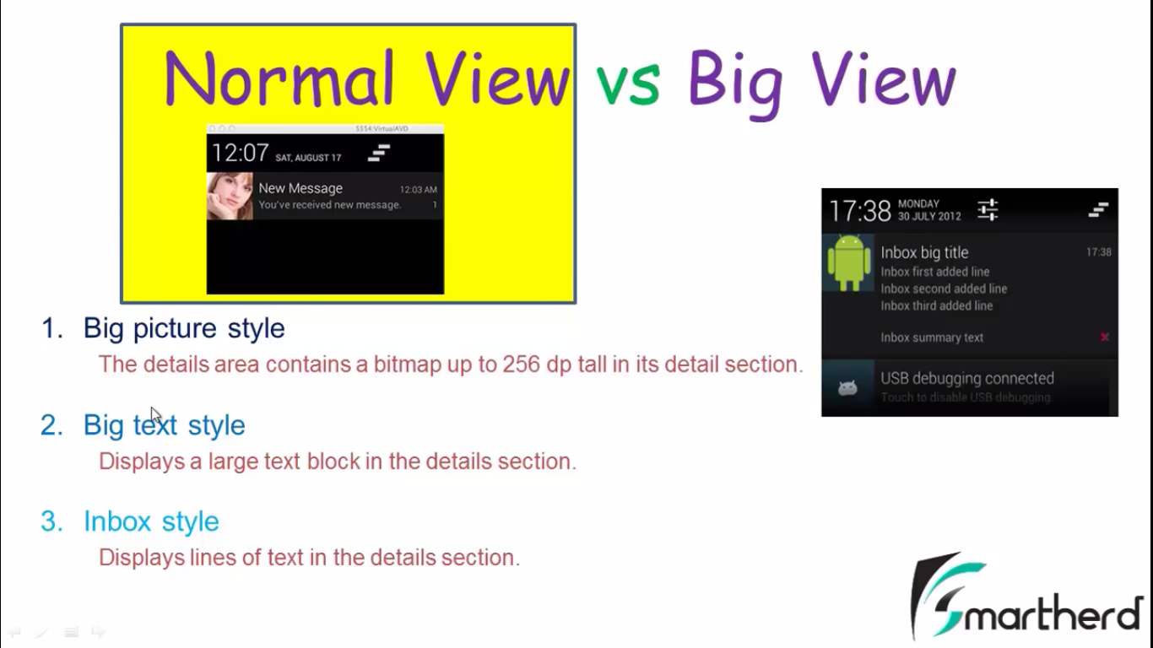

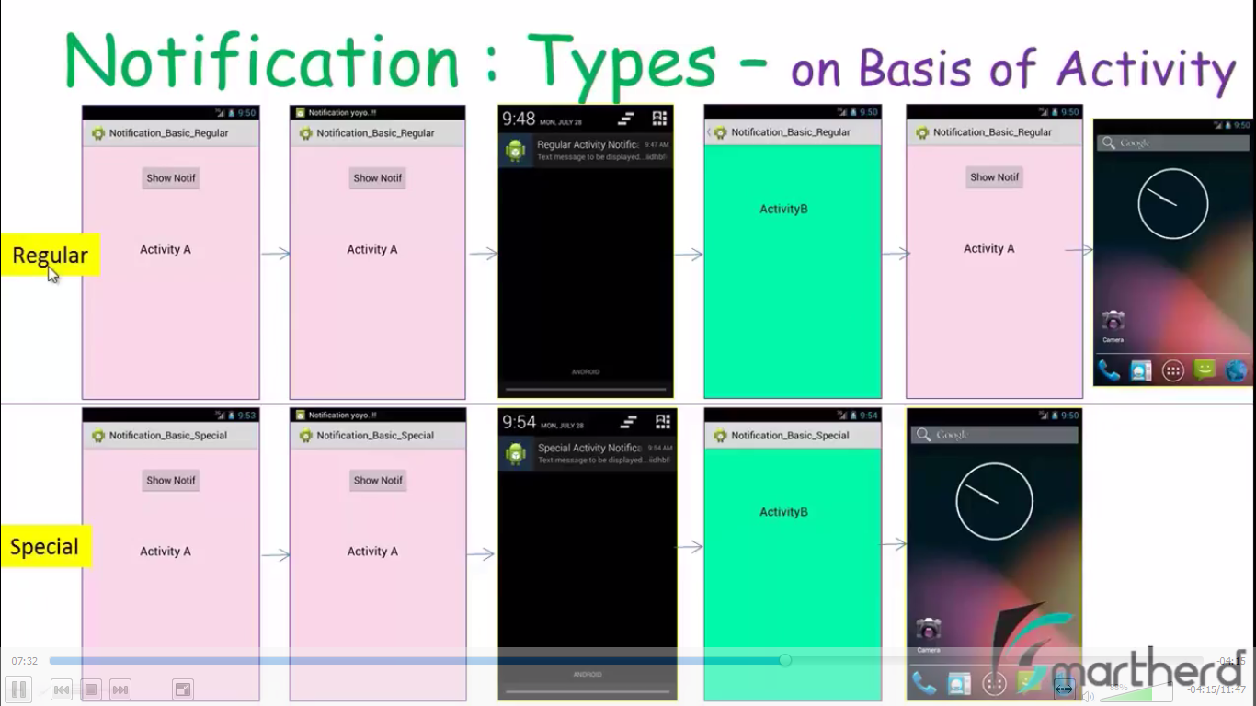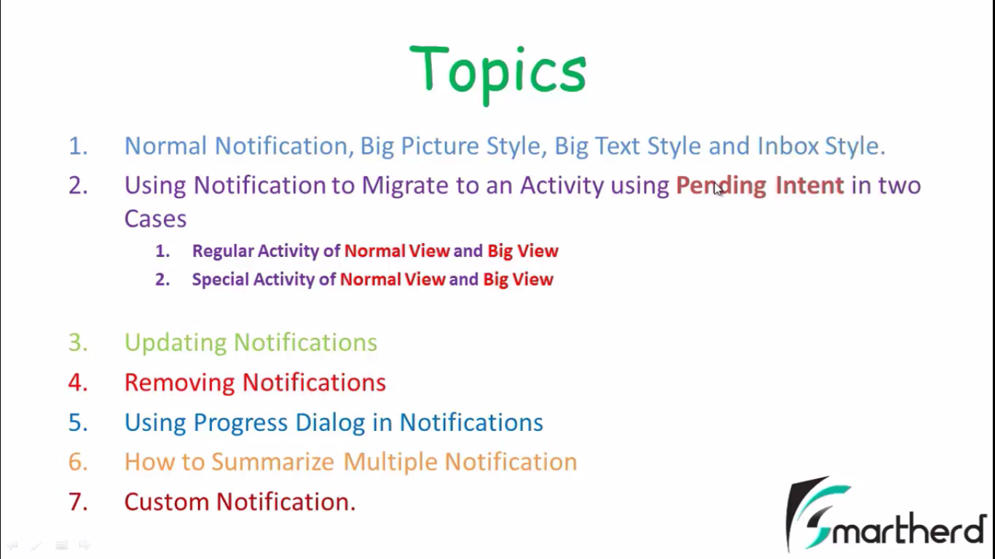 **REGULAR ACTIVITY NOTIFCATION:**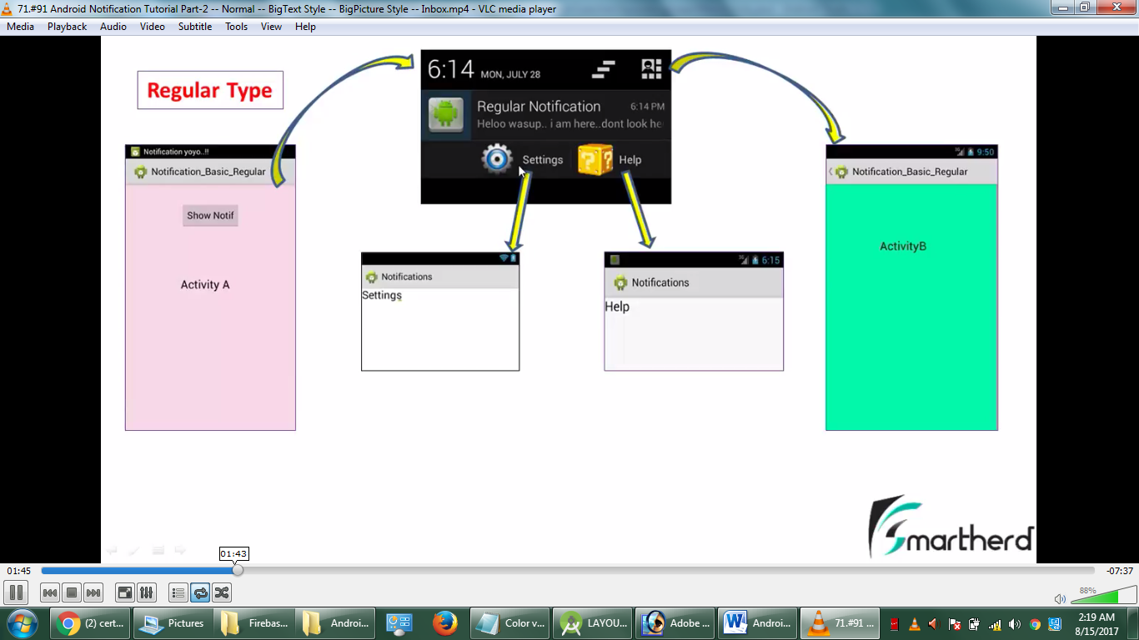

**INTENTS:**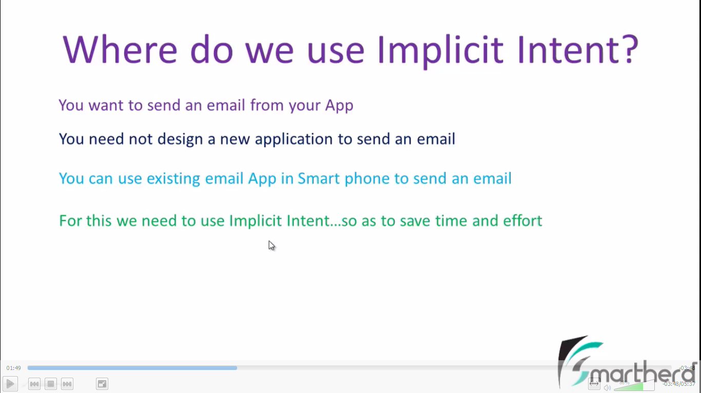

**EXPLICIT/IMPLISIT INTENTS**

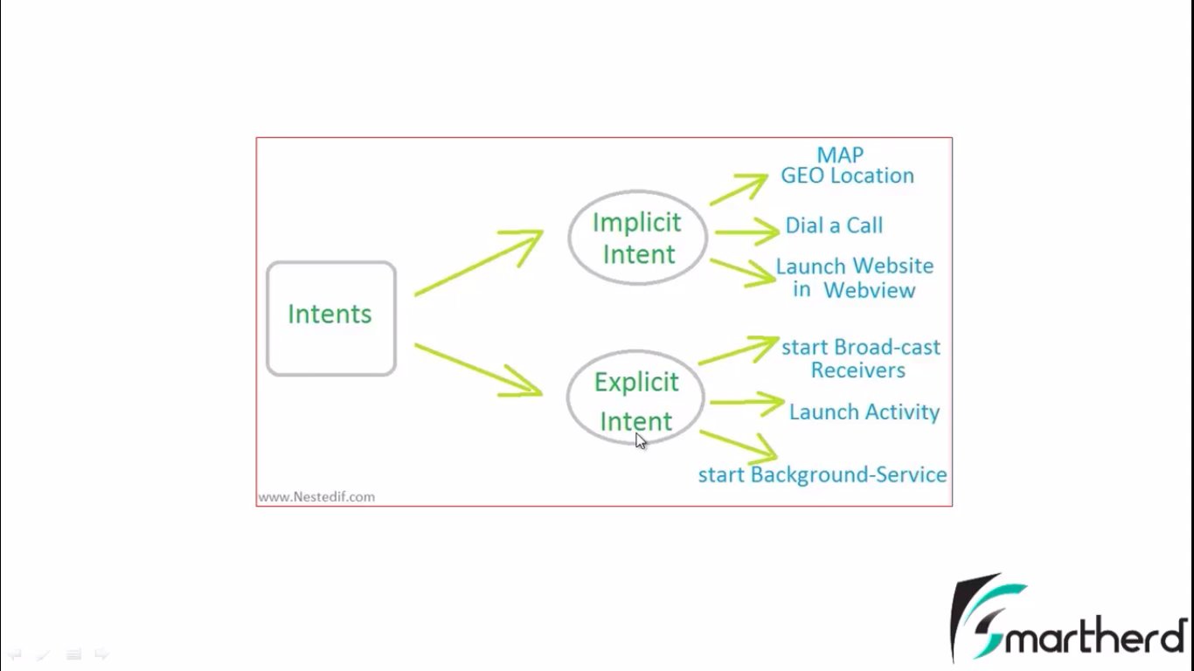

**BIG PICTURE NOTIFICATION**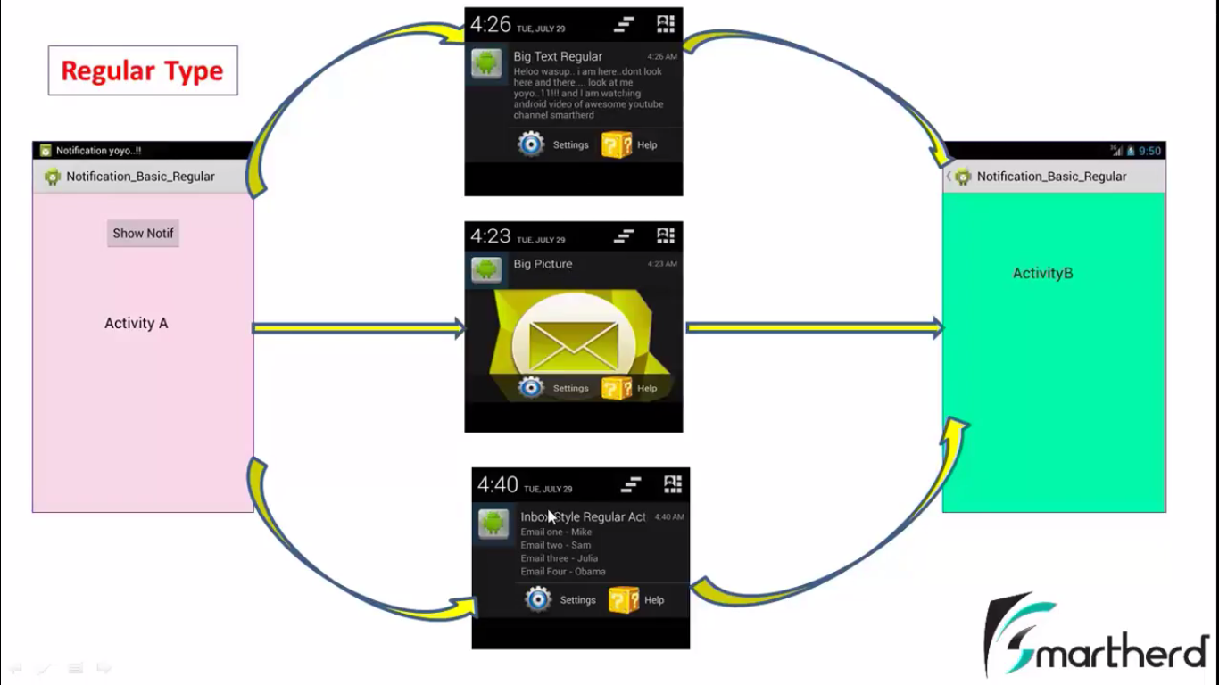

**SPECIAL INTENTS NOTIFICATION**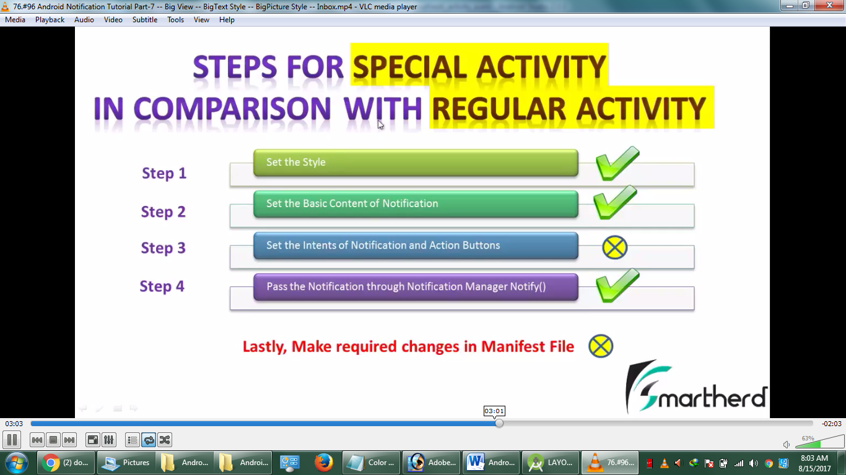

**TextToSpeech :**

**CODE**

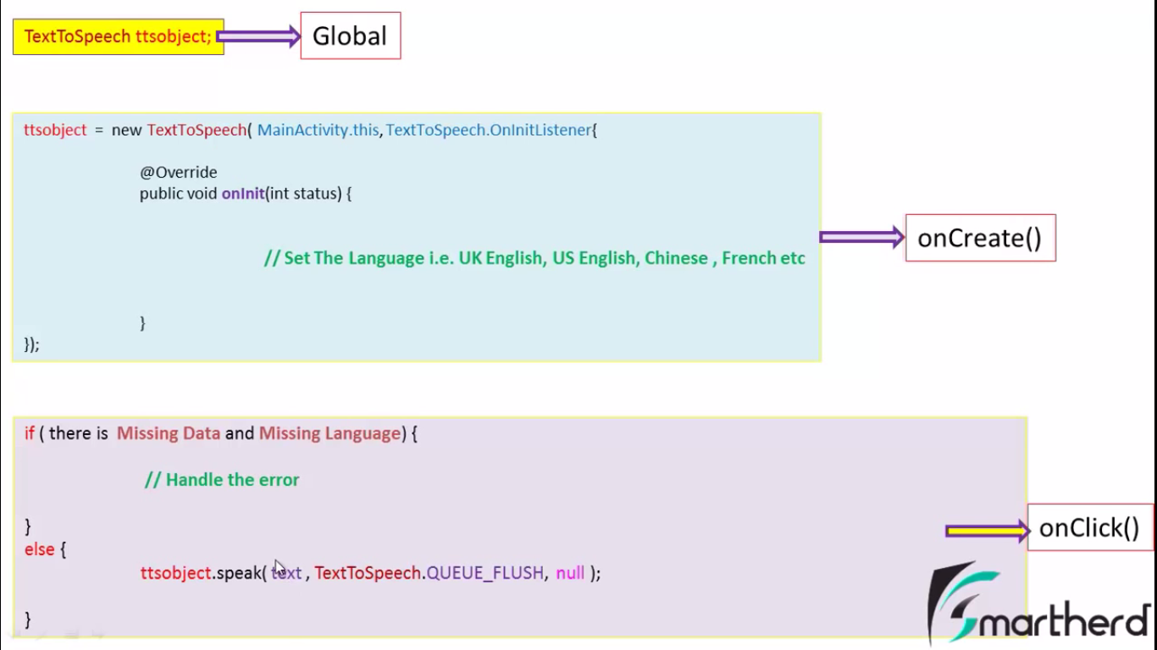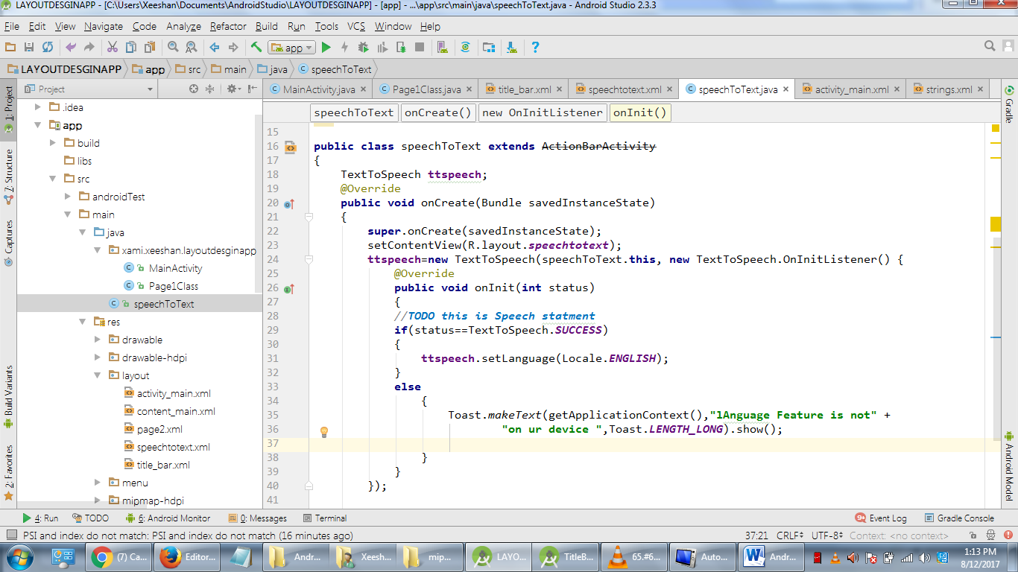

**Pre-define Exceptions**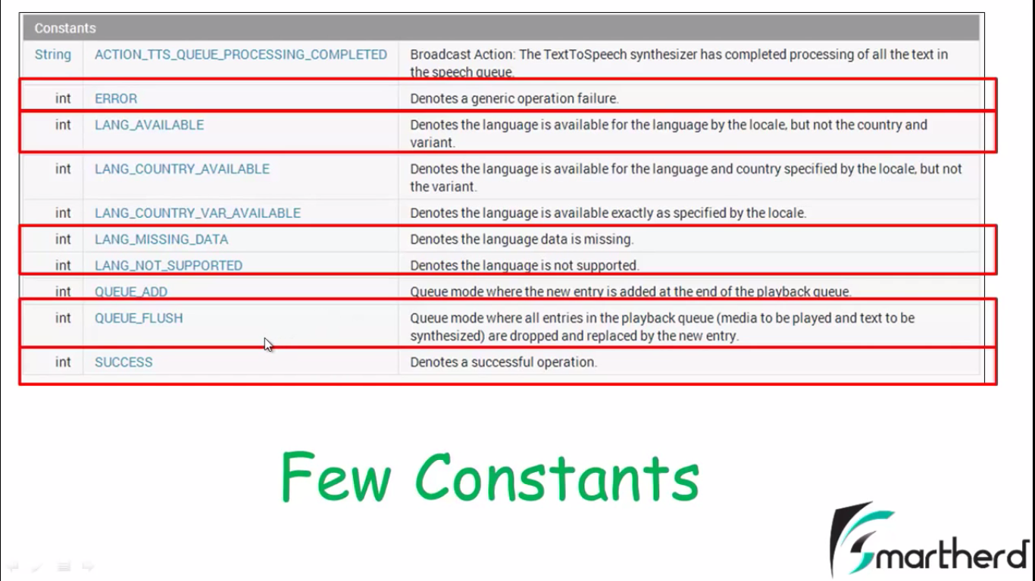

**Padding:Margin:**

MAR

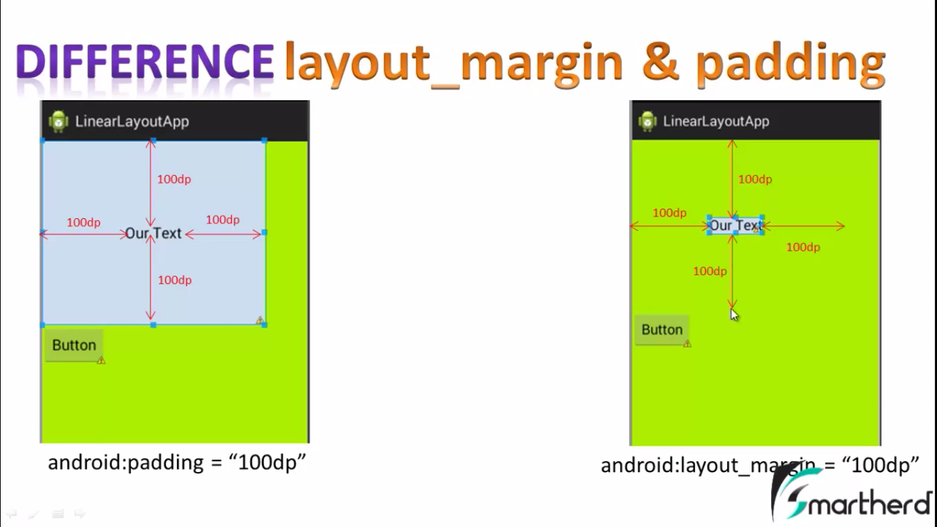

**InTool**

**android:paddingBottom="10dp"  
android:paddingLeft="10dp"  
android:paddingTop="10dp"  
android:paddingRight="10dp"**

**LAYOUT int Screen**

**Margin**

**android:layout_marginBottom="100dp"  
android:layout_marginLeft="100dp"  
android:layout_marginRight="100dp"  
android:layout_marginTop="100dp**

**Padding**

**android:layout_paddingBottom="100dp"  
android:layout_paddingLeft="100dp"  
android:layout_paddingRight="100dp"  
android:layout_paddingtop="10dp"**

**weightSum & layout_wieght**

<**LinearLayout xmlns:android="http://schemas.android.com/apk/res/android"  
 android:layout_width="match_parent"  
 android:layout_height="match_parent"  
 android:orientation="horizontal"  
 android:weightSum="5"** >  
  
  
 <**TextView  
 android:layout_weight="1"  
 android:id="@+id/textView1"  
 android:layout_width="0dp"  
 android:layout_height="wrap_content"  
 android:gravity="center"  
 android:text="TextView"  
 android:textSize="30dp"  
 android:paddingBottom="10dp"  
 android:paddingLeft="10dp"  
 android:paddingTop="10dp"  
 android:paddingRight="10dp"** />  
  
 <**TextView  
 android:id="@+id/textView2"  
 android:layout_width="0dp"  
 android:layout_height="wrap_content"  
 android:layout_weight="1"  
 android:gravity="center"  
 android:paddingBottom="10dp"  
 android:paddingLeft="10dp"  
 android:paddingRight="10dp"  
 android:paddingTop="10dp"  
 android:text="TextView"  
 android:textSize="30dp"** />  
  
 <**TextView  
 android:id="@+id/textView3"  
 android:layout_width="-0dp"  
 android:layout_height="wrap_content"  
 android:layout_weight="1"  
 android:gravity="center"  
 android:paddingBottom="10dp"  
 android:paddingLeft="10dp"  
 android:paddingRight="10dp"  
 android:paddingTop="10dp"  
 android:text="TextView"  
 android:textSize="30dp"** />  
  
  
</**LinearLayout**>

**TEXYSIZE : SP=Scale Size  
Screen LAYOUTS**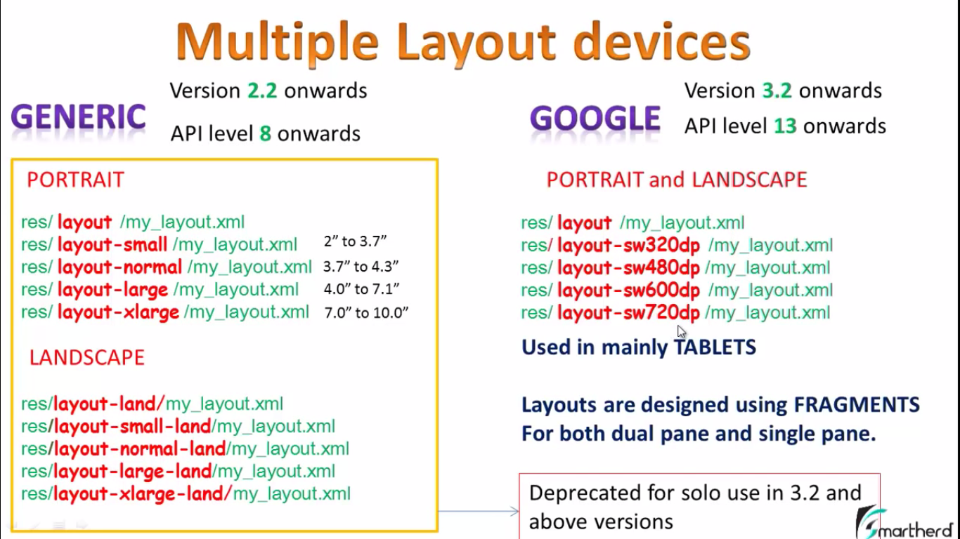

.Xml file for layout design of anroid

.java file programming of the android

**Javac Cmd Prompt** : C:\Program Files\Java\jdk1.8.0_12\bin

**BuildGaled:** All dapendancies in here Versions Target run application_Packages Name uner tha package config etc  
**GradleFIle**: Application Model its have file app Depandies package name, Version Name app related data.

**Assets Folder** have Miscillious files it also contain **Raw Data**.  
Audio,Fonts ,images, text files non android xml files .xml  
**Drawable Folder** Image Layout.  
**Layout Folder** Contain xml Files. Interface of app *(activity _main.xml)  
**Values Folder.** Contains string.xml **(Text🡪 Hellow World etc)   
 <resource><string>abc</string></resource>   
MainActivity OF java File** it is in app🡪 java🡪 **main_activity.java**

**COMPONENTS OF ANDROID:  
Activity,Service ,Broadcast Reciever, Content Provider.**

**Activity🡪 is that her wo cheez wo app jo hum mobile main ki app main use kerty hain compose msg send msg etc.Itis also provide a userinterface.**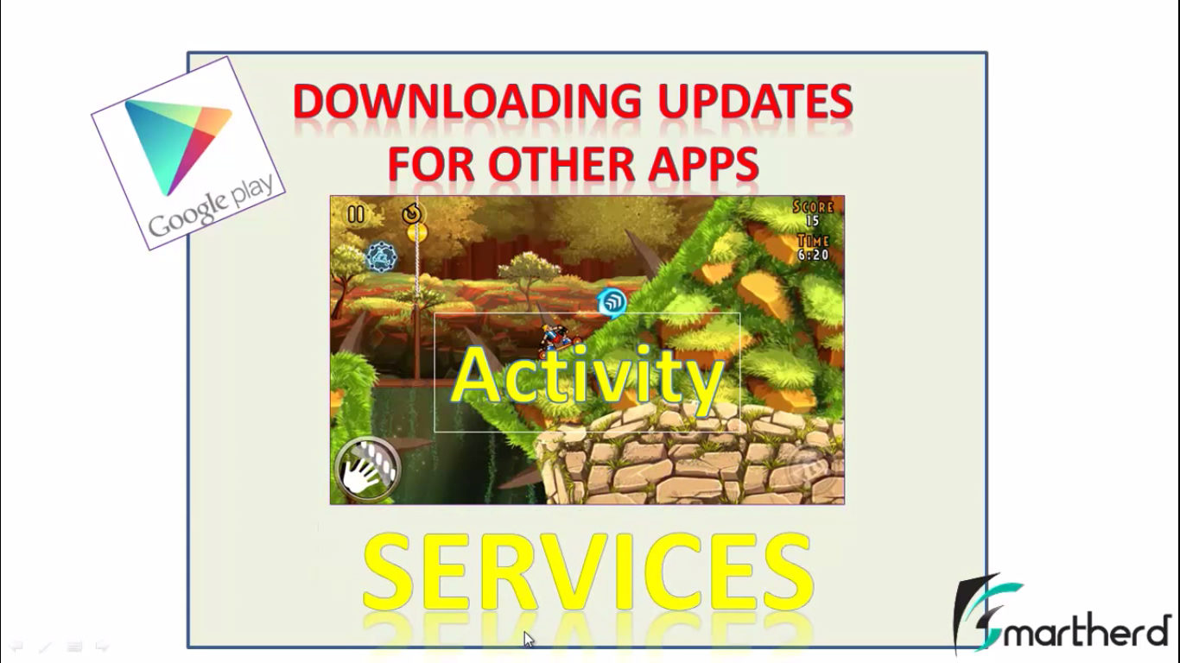

**Services🡪 is a component s run app in background like any msg or notification get bcz background application is running .it is remote process Service does not provide a use interface  
BroadCast Reciver: 🡺 In Android OS Dialog prompt using the any application or disturbance create like pop up Bettry low ,receive msg, email notification front of screen called broadcast Reciver.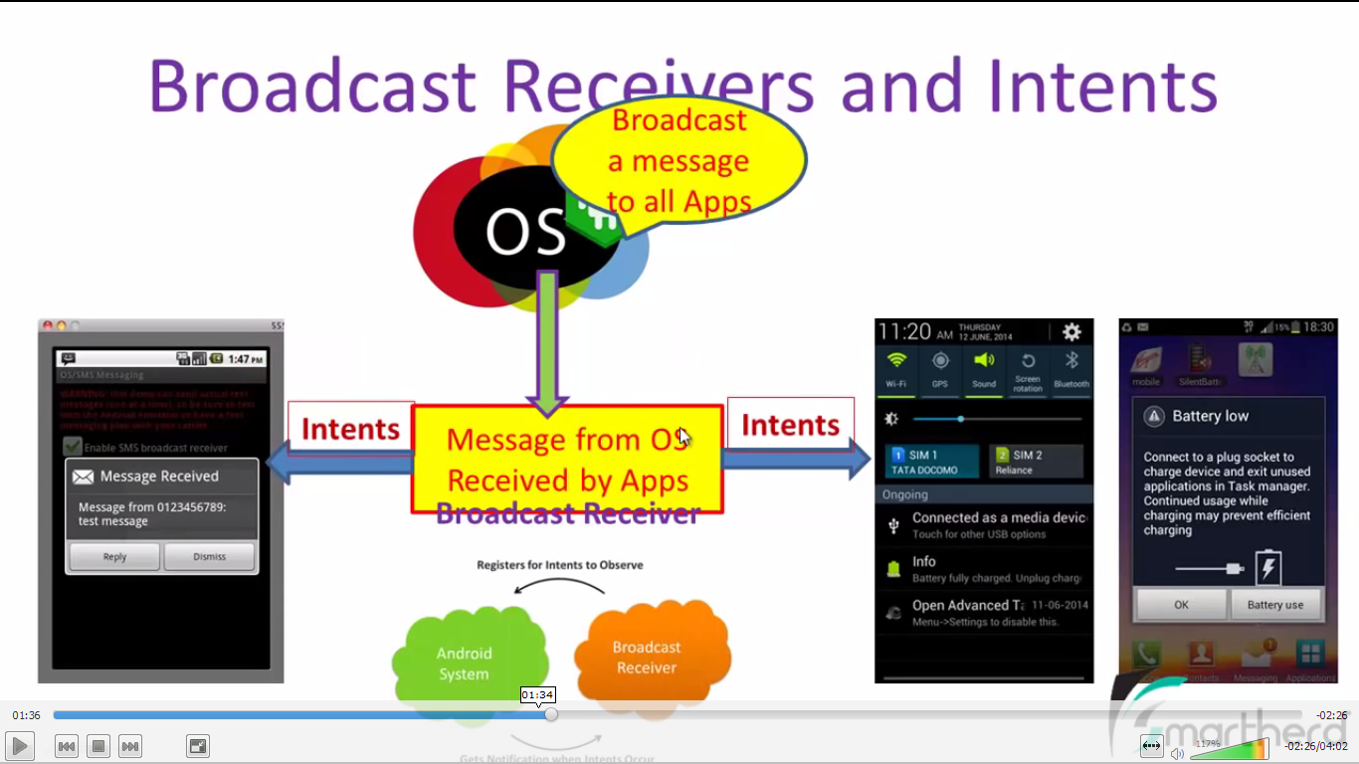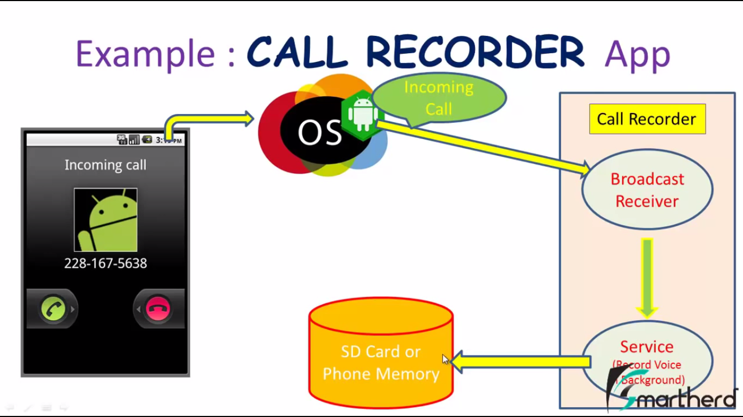 Explict Intents/Implict Intens.: 🡪**It is the entry Point of any application  
One Activity to move to antother actvty like gmail inbox to compose msg box screen… etc using Intents.  
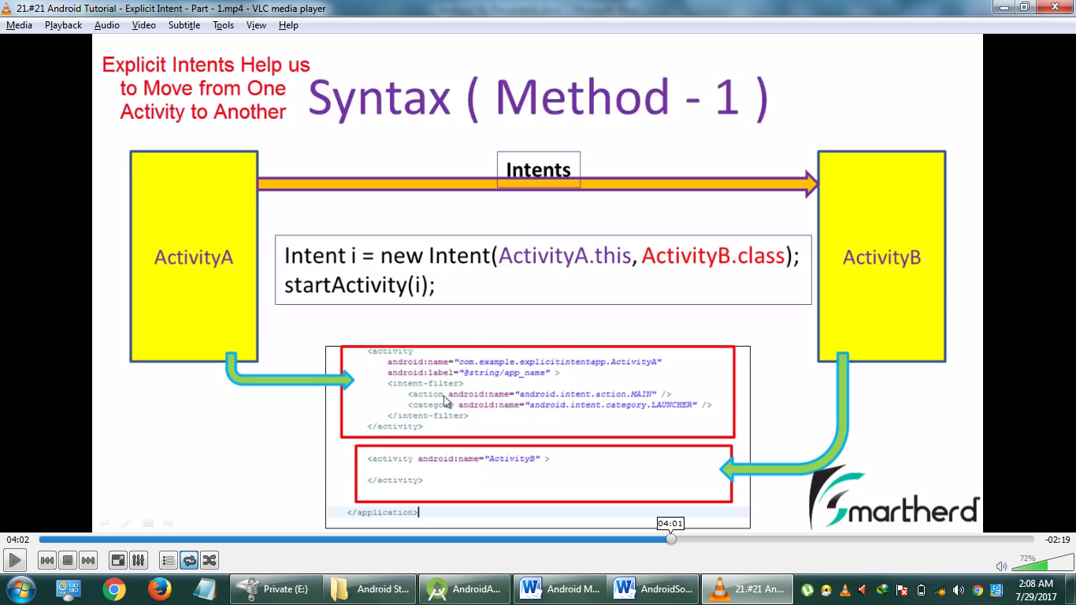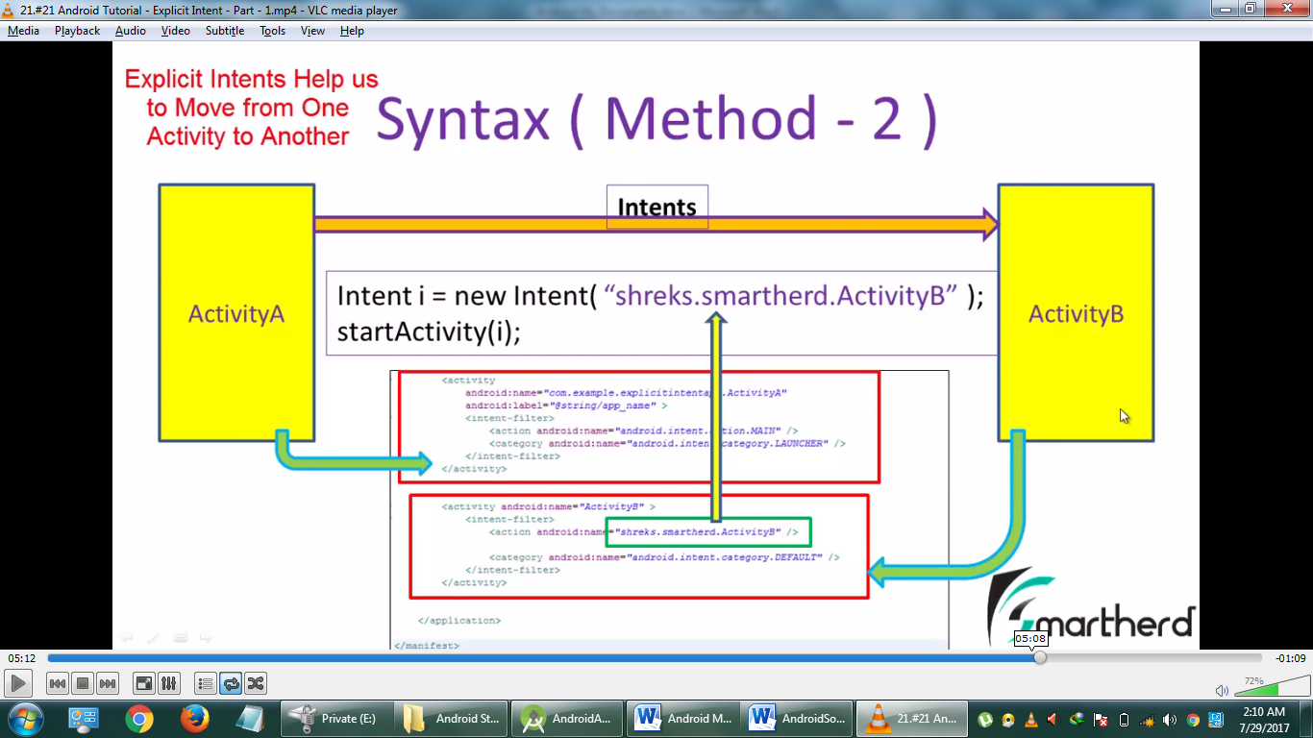

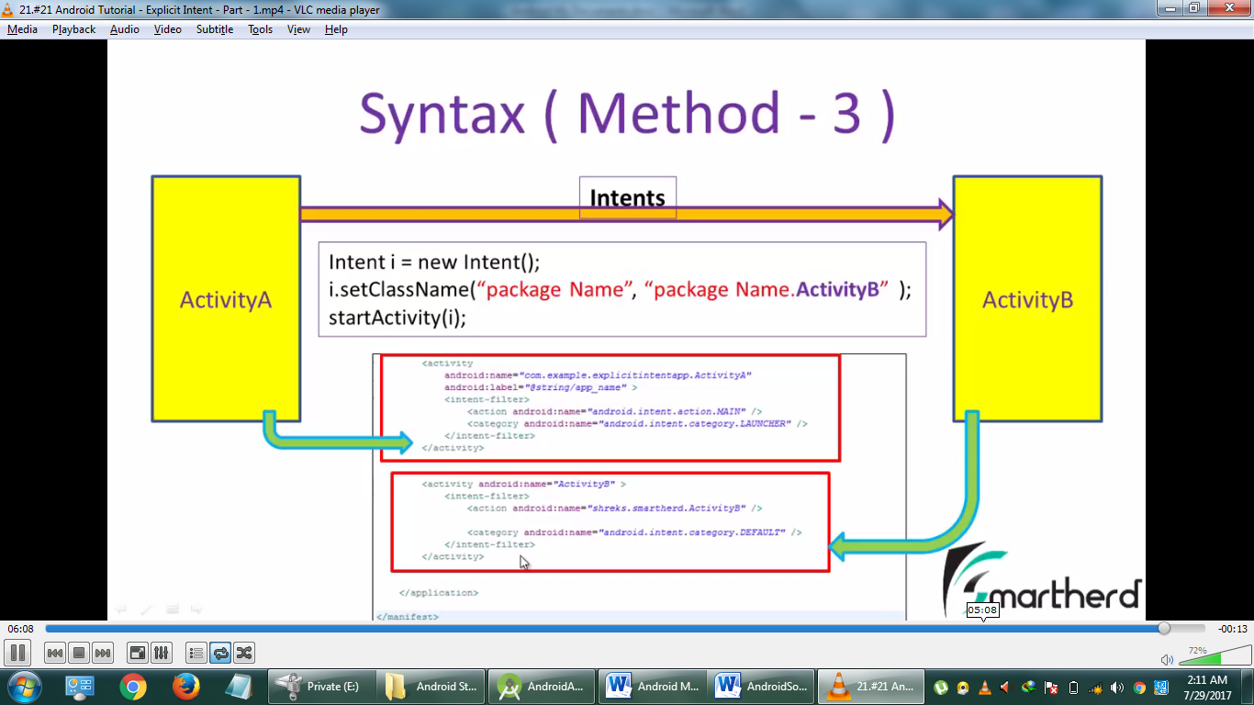

**<activity>**

**<intent-filter>**

**<action android:name=”android.intent.action.Main” />  
 <category android:name=”android.intent.category.LAUNCHER” />  
 </intent-filter>**

**</activity>**

**Root_ID : it’s the linear layout in mention also called parent ID**

**ChildID in wedgets tools is in tags**

**______________________**

**CUSTOME_Toast: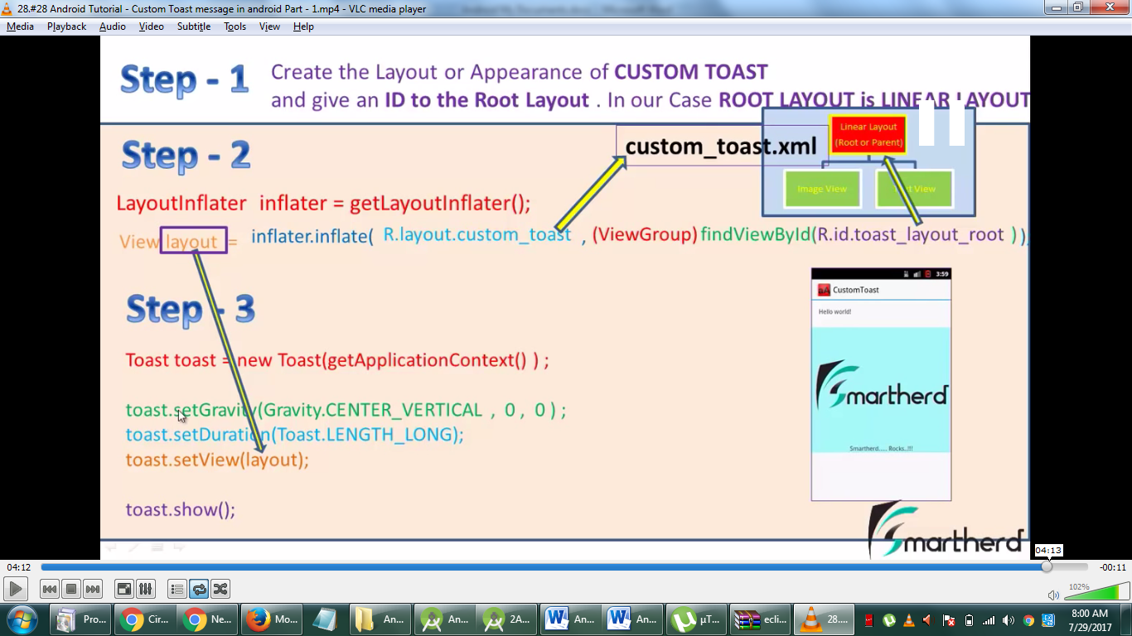 -----------------  
TOAS (Small Popup onto the ur Screen)**

**Toast toast=Toast.makeTest(context,String,duration)**

**toast.show();**

**Context(where u want to display ( msg))**

**-------**

**JAVA Main Method Start the App And Much more: (LIFE CYCLE OF APPLICATION PAGE 1 & PAGE 2  
Oncreate()_ ,OnStart(), OnResume, OnPause, OnStop, OnDestroy, OnRestart**

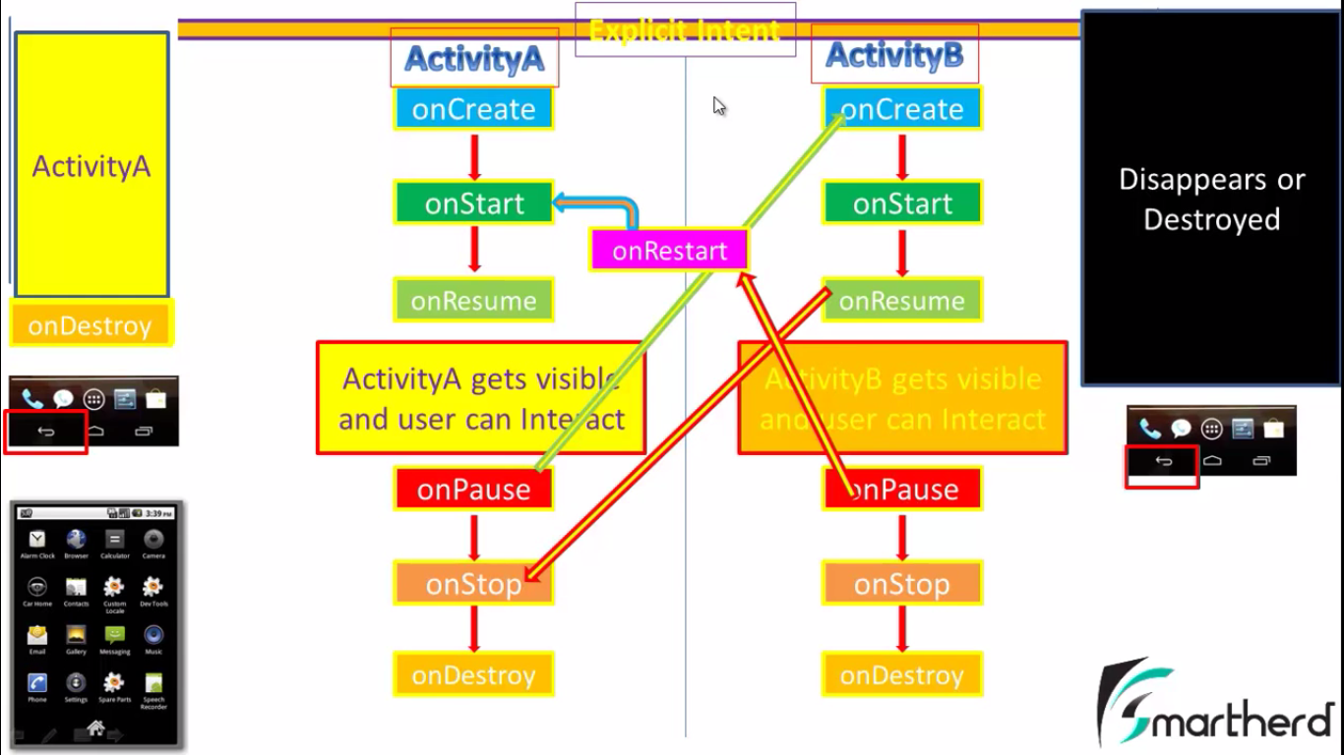

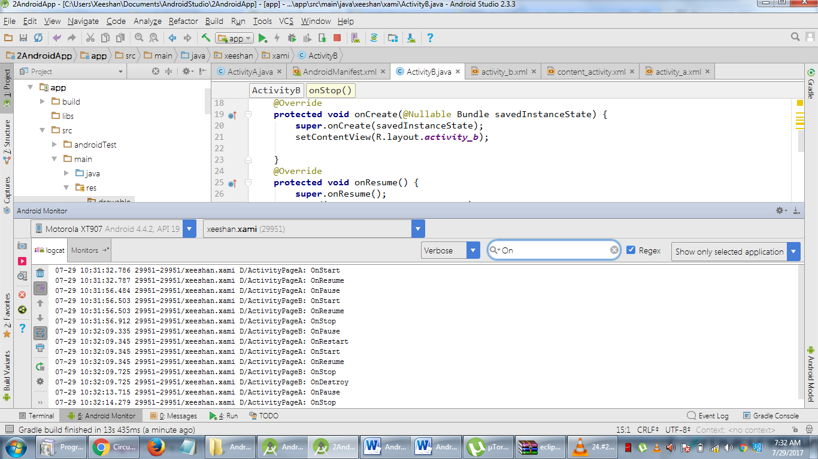

**-------------------  
  
MAIN ENTRANCE CODE OF ANDROID APPLICATION:**

**MainActivtiy**

**Import android.app.Acitiivity;**

**{**

**Public class Mainactivity extends Activity{**

**@override   
protected void OnCreated (Bundle saveInstanceState)**

**{**

**Super.OnCreate (saveInstanceState);**

**setCOntentView(R.layout.activity.main);**

**}  
}**

**}  
Its in ANDROIDMAINIFEST.xml**

**<manifest>**

**It have version app name and exectra object about ur app/project  
</manifest>**

**View and ViewGroup**

**Linear Layout**

**1.vertical  
 2.Horizontal**

**ListView  
Relative**

**GridView**

**FrameLayout**

**Table Layout**

**WRAPCONTENT :  
Those tools contains toots width and height jst  
MATCHCONTENT :**

**Entir Contain all space of the viewGroup Layouts of any tool.**

**LOGCAT: (it help us to that any Error Containt it send to PRINT ErrMsg in below class..)  
ErrorMethod:   
 Clas Methods**

**V(String,String)** Verbose Less Priority **d(V(String,String) debuge  
 i(V(String,String) information  
 w(V(String,String) warning   
 e(V(String,String) error High Priority.**

**Tag Msg  
LOG.V(“String ”,” String”);**

**Two-Types OF OnClickListner:**

**Object Base like**

**FeatureName.setOnClickListner(new OnClickListner(){**

**@Overrdie  
public void OnClick(View v)**

**{**

**//Action Performed**

**}**

**AnOther Click Event Which is Defined in XML Code in any performerTools**

**XML Code:**

android:OnClick=”performAction”

**javaCode: MainActivityFile**  
@Override

publice void PerformAction(View v)

{

//ActionPerform which type you want

}

**XML Android:**xml ka Linear layout out best hota hai relative By Defualt hota hai Linear main Jst Horzontal aur vertical Wedgets dal skty hen aur Relative me kahi b  
  
**API Keys:**

Each Google Map web services required APi ket & client keys.Api key free available with google account . <https://developers.google.com/console>. First you type to need Api key so u must add a server keys

1. Visit <https://developers.google.com/console> and log in with a Google Account.
2. Select one of your existing projects, or create a new project.
3. Enable the API(s) you want to use. The Java Client for Google Maps Services accesses the following APIs:
   * Directions API (Google Maps APIs Predictive Travel Time Feature)
   * Distance Matrix API (The Google Maps Distance Matrix API is a service that provides travel distance and time for a matrix of origins and destinations.)
   * Elevation API
   * Geocoding API
   * Places API
   * Roads API
   * Time Zone API
4. Create a new **Server key**.

**Android Package Kit (APK)**

1. JAR and ZIP. **Android Package Kit** (APK) is the package file format used by the Android operating system for distribution and installation of mobile apps and middleware.

**cameraTilt:**

A *tilt* is a vertical camera movement in which the camera points up or down from a stationary location. For example, if you mount a camera on your shoulder and nod it up and down, you are tilting the camera.

**OOPL:**

**Class:** Ek Class Userdefine data type hoti hai yeh ek blueprint and template base hoti hai jis main hamara Data Object Form main rkha jata hai aur Data say action perform kia jata hai.

Class k Blueprint say instance create kerty hain. Aur in instance ko hum Object Kehty hain

**About Android:**

What’s more, Google has recently released their latest version of the Android SDK — 4.0, a unified mobile OS for both smartphones and tablets. The Android 4.0 SDK includes several new features for tablet developers, and understanding all these new features requires some effort on the part of beginners.  
**Data Persistence**  
Shows you how to save, or store, data in your Android application. In addition to learning the various techniques to store user data, you will also learn file manipulation and how to save files onto internal and external storage (SD card). In addition, you will learn how to create and use a SQLite database in your Android application.

**-google.map.xml**   
Android->app->res->value->google.map.xml

**JAVA Program:**

**Output:**System.out.println(“string”);

**Input:   
VOID:** Nothing (in main methid main kch return nh kerta)

PROGRAM: Method Overloading Ek hi Name k Diff Func With Diff Parameters

package learningpointjava;

class FreshJuice {

public void sum(int a,int b,int c)

{

System.out.println("this is my sum "+(a+b+c));

}

public void sum(int a,int b)

{

System.out.println("this is my sum "+(a+b));

}

public void sum(int a)

{

System.out.println("this is my sum "+(a));

}

}

class LearningPointJava extends FreshJuice{

public static void main(String args[])

{

FreshJuice FJ=new FreshJuice();

FJ.sum(10);

FJ.sum(10,20);

FJ.sum(10,20,30);

}

}

SUM PROGRAM 2 Classes:

package learningpointjava;

class FreshJuice {

int a=10;

int b=20;

int c=a+b;

}

class LearningPointJava extends FreshJuice{

public static void main(String args[]) {

int a=0;

for(a=0;a<10;a++)

{

System.out.println("Zeeshan");

a++;

System.out.println("Sami");

}

}

}

**ARRAY:**package learningpointjava;

class LearningPointJava {

public static void main(String args[])

{

int Array[] ={0,1,2,3,4};

System.out.println(Array[0]);

}

}

**FOREACH AN ARRAY:**package learningpointjava;

class LearningPointJava {

public static void main(String args[])

{

int x[] =new int [5];

for(int i=0;i<x.length;i++){

x[i]=i;

}

for(int element:x ){

System.out.println(element);

}

}

}

**CONSTRUCTOR: (**Constructor yeh allao kerta hai k Same Nam ki Class k Object ko naam sy Ek method hota hai jo k main method main Object Create hony per bina call karae chl jata hai aur yeh public hota hai her class main bydefualt ek Constructor Hota hai Exm Below**)**

package learningpointjava;

class box

{

double w=10,l=10,h=10;

box()

{

System.out.println("this is my first constructor in java");

}

double volume()

{

return(w*l*h);

}

}

class LearningPointJava {

public static void main(String args[])

{

box obj=new box();

double v=obj.volume();

System.out.println(v);

}

}

**INHERITENS: (**Ek Class k Fields,Members,Objects,Properties,methods,Data,ETc,Allow kerta hai dusri class sy **extends** k keywords sy kisi dusri class main **exmp below** **)**package learningpointjava;

class box1

{

double w,l,h;

box1()

{

System.out.println("this is my first constructor in java");

}

}

class box2 extends box1

{

double volume(double x,double y,double z)

{

w=x;

l=y;

h=z;

return (w*l*h);

}

}

class LearningPointJava {

public static void main(String args[])

{

box2 obj=new box2();

double v=obj.volume(10,10,10);

System.out.println(v);

}

}

**SUPER: (**Super means jo class main Fields,properties,memebers,data, etc pehly wali class main Declear jo wo phle run hoga is Code k through **super.i exm below)**class check1

{

int i=10;

}

class check2 extends check1

{

int i=20;

void print()

{

System.out.println(i +" "+ super.i);

}

}

class LearningPointJava {

public static void main(String args[])

{

check2 obj;

obj = new check2();

obj.print();

}

**Acces Modifires:   
(Protected )(**Protected Just Extends wali Class main hi Work Krega **)  
(Private) (**Private Extends per b works nh krega Just Internally working main ayega**)  
(Public /Defualt) (**Public Extends features ho ya na ho sub main acces krega**)**

**package learningpointjava;**

**//-------------For Acces Modifires**

**class box1**

**{**

**protected double w=1,l=2,h=3;**

**box1()**

**{**

**System.out.println("this is my first constructor in java");**

**}**

**}**

**//----------main Function**

**class LearningPointJava extends box1 {**

**double volume()**

**{**

**return (w*l*h);**

**}**

**public static void main(String args[])**

**{**

**LearningPointJava obj2=new LearningPointJava();**

**obj2.volume();**

**}**

**}**

**INTERFACES: (**Jub Humain Ek hi Method ko EK hi naam ka aur same Parameters sy kam Lena ho alg alg classes main to hum **Interfaces** ka use kerty hain **Exe:below)  
package learningpointjava;**

**{**

**interface math**

**{**

**public double area(int r);**

**double pi=3.142;**

**}**

**class type1 implements math**

**{**

**public double area(int r)**

**{**

**return(pi*r*r);**

**}**

**}**

**class type2 implements math**

**{**

**public double area(int r)**

**{**

**return(4*pi*r*r);**

**}**

**}**

**//Interfaces**

**class Zeeshan**

**{**

**public static void main(String argsp[]){**

**type1 Circle=new type1();**

**type2 Sphare=new type2();**

**double c=Circle.area(3);**

**double s=Sphare.area(5);**

**System.out.println("Sphare : "+s);**

**System.out.println("Cicle : "+c);**

**}**

**}**

**}**

**EXCEPTION HANDLING: (**Jub Koi Syntax k Ilawa Logical Error jha Lagy k error askta hai hmry Program main to wha hum **Try Catch EXCEPTION** Use kerty hain **Exe below)**

**package learningpointjava;**

**public class ExaptionHandling {**

**public static void main(String args[]){**

**int a=10;**

**try{**

**int b=20/0;**

**System.out.println("Error : OK");**

**}catch(Exception e)**

**{**

**System.out.println("this is arithmetic Error Exception");**

**}**

**}**

**}  
ArrayIndexOutOfBoundsException: (**Array Exception jUB Boundry main ajae to is naam ki exception sy isko pkrty hain **Exe below)**

**package learningpointjava;**

**public class ArrayIndexOutBoundsException {**

**public static void main(String args[]) {**

**int arr[]=new int[5];**

**try{for (int i=0;i<10;i++){**

**arr[i]=i;**

**System.out.println(arr[i]);**

**}**

**}catch (ArrayIndexOutOfBoundsException e){**

**System.out.println(e);**

**}**

**}**

**}**

### **User-Define Exceptions** [Create your custom exception in Android](https://muratonnet.blogspot.com/2013/08/create-your-custom-exception-in-android.html)

POSTED BY MURAT ARAS ON MONDAY, AUGUST 26, 2013 / LABELS: [ANDROID](https://muratonnet.blogspot.com/search/label/android)

Exception handling is one of the most important thing when we are developing application. A lot of programming languages has exception handling mechanism and has lot of pre-defined exception types. For example, FileNotFoundException, NullPointerException, etc.   
  
Also, when we are developing an application, time to time we want to create own exception(s) for meaningful errors and easy handling. For example, UserNotFoundException, EmployeeAlreadyExistsException, etc.   
  
How can we create our custom exception in Android?   
Everyting we need is our exception class which is extends from an [Exception](http://developer.android.com/reference/java/lang/Exception.html) class.   
  
Let's create a UserNotFoundException.

public class UserNotFoundException extends Exception {

public UserNotFoundException() {

super("User not found.");

}

}

That's all. Now, we are throwing an exception;

public User getUser(int userId) throws Exception {

// get user from database

User user = ...;

// check user

if (user == null)

throw new UserNotFoundException();

return user;

}

and catching

public void myFunction()

{

try {

User user=getUser(999);

} catch (UserNotFoundException e) {

// now, we know user cannot be found in database

// write spesific log, show specific message to user, etc.

}

}

Of course, you can extend your exception class for additional and detailed informations and properties.

**JAVA JDK Defualt Class** Exception: **(**Yeh User Defined Exeption hoti hain jo Hum Khud Hanlde Kerty hain **Exe Below)**  
class num5 extends Exception{}  
package learningpointjava;

class numbExcep extends Exception

{

numbExcep(int w){

System.out.println(w+" this is Illegal number of exception ok!!!");

}

}

class numbers

{

public static void trial(int i) throws numbExcep

{

if(i==5)

{

throw new numbExcep(i);

}

}

public static void addNumber(int r)

{

try

{

for (int k=r; k<10;k++)

{

System.out.println(k);

trial(k);

}

}catch(Exception e)

{

System.out.println(e);

}

}

}

public class UserDefinedException {

public static void main(String args[])

{

numbers.addNumber(1);

}

}

**THREADS: (Threads** Means k konsi Line of code kis wqt main Run kre Basically Comp Khud hi Runtime Decide kerta but **thread** sy hum Timing Set kerskty hain like thread **sleep** function **sleep**(**1000**) ek sec k wqt sy Actually PC yeh Monitor kerta hai konsa kam pehly hoga priority kisko deni hai**Exe Below)**

**package learningpointjava;**

**public class Threading {**

**public static void main(String args[]){**

**Thread t=new Thread();**

**try{**

**for (int i=0;i<10;i++){**

**System.out.println(i);**

**t.sleep(1000);**

** }**

**}catch(InterruptedException e)**

**{**

**System.out.println(e);**

**}**

**}**

**}**

**}**

**ENUMURATION: (**Jub koi Constant Data of set fixed kerna hai as a value type like **Color.Red**  tb use kiye jaty hen **Exe below)  
class Enum**

**{**

**public enum WeekDay{sun,mon,tues,wed,thrus,fri,sat}**

**public static void main(String agrs[])**

**{**

**for(WeekDay s:WeekDay.values())**

**{**

**System.out.println(s);**

**}**

**}**

**Abstract Class: (** You cannot create Instance or Object of abstract class**)**

**PACKAGES: (**Ek Packages main Sirf Class,SubPackegs,Interfaces Askty hen means collection of classes**)  
(**Packages means yeh hota hai k Jis Folder/Project main rehkr Classes use ki jaen Agr Ek Project Kisi Dusry Project ki File/Class/Pakages use kerna hoto **IMPORT** ki commandsy Use kerty upper Namespaces ki jaga per**)**

**Final : (Final** keyword agr kisi class k sath mention hojaegea to us class ko kisi dusri class sy inherit nh krskty hain means **exe below** **)**Final Class A{}  
ClassB extends ClassA //its not inherit form Class A

**Super: (Super**  Keyword hai Jo Hum Sub sy Super Class k methods/Properties/Fields ko Use kerny k kaam ata hai**)  
  
Polymorphism: (**Polymorphism main same naam k function ho chahy ek class main ho means parents main ho ya child main ho jiska signature yani parameters differents ho aur complie time pe compiler yeh dicide kere k konsa method run hoga to usy **method** **Overriloading** **Polymorphism** kehty hen **Exe below)  
Obsulute C++**C++ main Function Overloading nahi hoti thi usmain Function Hidding hoti thi child wala Funciton Parent walay Function ko hide kerdeta tha jubky java main esa nahi hota.

**package learningpointjava;**

**class A**

**{**

**public void method(int a)**

**{**

**System.out.println(a+"Class A Called");**

**}**

**}**

**class B extends A**

**{**

**public void method(int a,int b)**

**{**

**System.out.println(b+a+"Class B Called");**

**}**

**}**

**public class methodOverloading**

**{**

**public static void main(String args[]) {**

**B obj=new B();**

**obj.method(2);**

**obj.method(2,3);**

**}**

**}  
Arguments ? diff Parameters ?:**

Value passthrough Function when calling called **arguments** 🡪 **Method(**4,5**);**  
Received value from an function called **Paramets e:g 🡪 Method(**int a,int b**);**

**Overrinding Method: (**yeh b same Overrloading ki trha hi hota hai but yeh same class main nh hoty han inky signature same hony chahiye jesy Class A ek Function Method(int a) to Class B yani Childe ya jisy Sub class bhi khety hen usmain b same naam ka signature ka function hona chaiye ek class main hoga to Overrloading kehlaega overriding nh OVerrding k liye yeh zaruri hai k alg class main ho aur same name and signature ho **Concept:** yeh k Sub/Child Class Parent/Super k function ko Override kerdeta hai Q k Obj Jis Class hoga usi ka original Function Execute hoga Overriding name aur signature dno hi same hony chahiye **exe below)**

**package learningpointjava;**

**class CarA**

**{**

**/* override this function*/ public void carGare(int a) //Normal Car**

**{**

**System.out.println("Normal Cargare are"+a);**

**}**

**}**

**class CarB extends CarA**

**{**

**public void carGare(int a) //Sports Car**

**{**

**System.out.println(" Sports carGare are "+a);**

**}**

**}**

**public class methodOverriding**

**{**

**public static void main(String args[]) {**

**CarB obj=new CarB();**

**obj.carGare(4);**

**}**

**}  
INPUT in JAVA:   
exe below:**

**/\***

**\* To change this license header, choose License Headers in Project Properties.**

**\* To change this template file, choose Tools | Templates**

**\* and open the template in the editor.**

**\*/**

**package learningpointjava.Keyword;**

**import java.util.Scanner;**

**/\*\***

**\***

**\* @author Xeeshan**

**\*/**

**public class iNput {**

**public static void main(String args[])**

**{**

**Scanner s=new Scanner(System.in);**

**System.out.println("Enter a Number");**

**int a=s.nextInt();**

**System.out.println("Print \n"+a);**

**}**

**}**

**OOP Features:  
Encapsulation(**Classes Object data ek class sy dusri class main inherit horha hai Classes/Inheritance/Polymorphism/Interfaces k through**)**

**Acces Modifiers  
Polymorphysim  
Interface  
Inheritence  
Method Overloading  
Method Overriding  
Class/Objects  
Methods  
Data Hiding  
Data Reusebilty**

**Wildcard:**

**GUI OF JAVA PACKAGES: (**Namespaces**)  
javax.swing  
java.awt;  
java.awt.event;**

**GUI Source Code:**/*

* To change this license header, choose License Headers in Project Properties.

* To change this template file, choose Tools | Templates

* and open the template in the editor.

*/

package learningpointjava.Keyword;

import javax.swing.*;

import java.awt.*;

import javax.swing.JFrame;

/**

*

* @author Xeeshan

*/

public class GUI {

public static void main(String args[])

{

JFrame J=new JFrame("Java Gui");

J.setVisible(true);

J.setBounds(200, 200,200,200);

J.setBackground(Color.black);

J.setForeground(Color.red);

}

}  
**ActionEvents: SourceCode:**package packegs;

import javax.swing.*;

import java.awt.*;

import java.awt.event.*;

class G implements ActionListener

{

public void intGui()

{

Container Con=new Container();

JButton b1=new JButton("Click Me naaa");

JFrame J=new JFrame("Java Gui");

Con=J.getContentPane();

J.setVisible(true);

J.setBounds(200, 200,200,200);

J.setBackground(Color.black);

J.setForeground(Color.red);

J.setLayout(null);

Con.add(b1);

b1.setBounds(50,20, 50, 20);

b1.setVisible(true);

// b1.addActionListener(this);

}

}

class test

{

public static void main(String args[])

{

G G=new G();

G.intGui();

}

}

**PASS DATA One Activity to Another Activity**

**Through the IntentPut Extra Method Passes the value**

______________________________________________

**Main Activity set the Method for Another Activity.**

String Val=edittext.getText().toString();

Intent intent =new Intent(MainActivity.this,SecondActivity.class);

intent .putExtra("NAME",Val);

intent.putExtra(("Description",description);

startActivity(intent);  
___________________________________________

**Second Activity get the values and methods**

textbox.setText()("Hello"+getIntent().getStringExtra("NAME");

textbox2.setText()("Hello"+getIntent().getStringExtra("Description

**DESIGN PATTERNS   
singleton:**A **singleton** in Java is a **class** for which only one instance can be created. It provides a global point of access this instance. The **singleton pattern** describe how this can be archived. **Singletons** are useful to provide a unique source of data or functionality to other Java Objects.